**SoSEAL semi-permeable barrier as a piping erosion risk reduction measure below dikes**

*Sterke Lekdijk Project, WAM SoSEAL Product Innovation*

Rocco Wennubst-Pedrinia 5329728

aTechnische Universiteit Delft, Postbus 5, 2600 AA, Delft, The Netherlands

Supervised by Dr. Frank Volkering (TAUW) and Dr. Timo Heimovaara (TU Delft)

16th of June 2022

 

Table of Contents

1 Company Reflection 4

2 Personal Reflection 10

3 Introduction 13

3.1 General Scope 13

3.2 Sterke Lekdijk Project 14

3.3 SoSEAL Technology 14

3.4 Scope of SS1.2. and Research Targets 16

4 Theoretical Background 17

4.1 Piping Theory 17

4.2 Piping Modelling 18

4.2.1 Current Practice 18

4.2.2 Modelling Strategy 19

5 Study Location 22

5.1 Representative Archetype – DP103 22

5.2 Geometry 22

5.3 Subsurface Data 24

5.3.1 CPT’s and Boreholes 24

5.3.2 Grain Sizes and Kozeny-Carman 25

5.4 Hydrological Characterization 26

5.4.1 Aquifer Hydraulic Conductivity 26

5.4.2 Lek River Water Levels 26

6 Model Design 27

6.1 Governing Equation 27

6.2 Numerical method 28

6.3 Cross Section and Boundary Conditions 28

6.4 Spatial Variability 29

6.4.1 Aquifer Hydraulic Conductivity 30

6.4.2 SoSEAL Hydraulic Conductivity 32

7 Model Results 34

7.1 Semi Permeable Barrier Principle 34

7.2 Piping Erosion - DP103 34

**7.2.1** **Uplift Check** 35

**7.2.2** **Heave Check** 36

**7.2.3** **Piping Erosion Check** 38

*7.3* *Design Verification* 44

8 Discussion 47

8.1 Modelling Approach 47

8.2 Result Analysis 47

9 Conclusion 49

10 Appendix 51

10.1 Additional Specifications 51

10.1.1 Annex A 51

10.1.2 Annex B 51

10.1.3 Annex C 51

10.1.4 Annex D 53

10.1.5 Annex E 54

10.1.6 Annex F 54

10.1.7 Annex G 55

10.1.8 Annex H 56

10.1.9 Annex I 56

10.1.10 Annex J 57

10.1.11 Annex K 57

10.1.12 Annex L 59

10.2 **Linear Approximation** 60

10.3 Laminar Flow 60

10.4 **Empirical Piping Criteria** 61

10.4.1 Foreland Damping 61

10.4.2 Sellmeijer 1989 and 2011 62

10.4.3 Lane and Bligh 63

10.4.4 HDSR (2017) 63

10.4.5 Overview of the Empirical Results 64

11 References 66

# Introduction

My (Rocco Wennubst Pedrini) internship at TAUW took place between the 17th of January until the 17th of June 2022. Based in the Rotterdam Capelle office, the internship contributed to the starting phase of the SoSEAL innovation development, in this case aiming at developing an in-situ alternative for dike safety against piping. The contribution to the project is presented in the report hereafter.

## General Scope

Water safety in the Netherlands is key in ensuring the country's vitality. A low-lying country, more than a quarter of land and half the population resides below sea level. Engineering theory and practice merge to ensure correct and safe operation of dikes and water retaining structures. High permeability layers are especially susceptible to instability below dikes when high water levels occur. Piping generally occurs when water retaining structures, subjected to a hydraulic head difference, are constructed above sandy foundations.

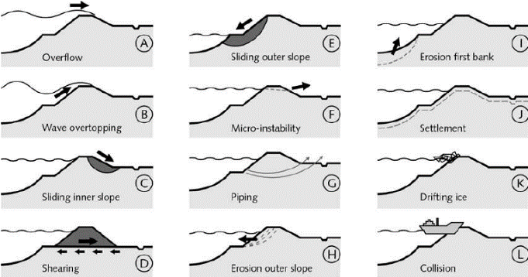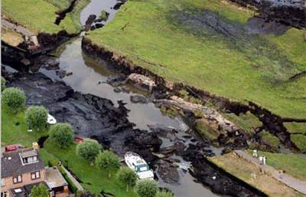

Figure - Left: Schematic of major dike failure modes (TAUW, 1998) Right: Horizontal peat levee failure at Wilnis in 2003 (Harteveld et al., 2007)

Macro instability of slopes and overtopping are well characterized and dominate as major failure mechanisms of dykes. Additionally, other mechanisms such as backwards erosion piping and associated slope instabilities pose significant risk. For example, statistical analyses of historic breaches in Hungary and Saxony show piping to account for 20% and 9.5% of failures respectively (Vorogushyn et al., 2009). The Netherlands has been less susceptible between 1134 and 2006 with only 1% of failures being attributed to piping (Baars and Kempen, 2009). Nonetheless, recent subsurface characterization and innovation initiatives call for additional research on the phenomena. Van Beek et al. (2010) developed full scale experiment with a seepage length of 15m. The findings showed the development piping erosion initiated by seepage through a cracked soft topsoil layer, sand heave and boil through the rupture, allowing retrograde piping erosion to onset. Such channel acts as a drain towards the rupture, whereby sufficient drag forces by rapid flow induce the rolling of grains. This is known as primary erosion. Once the pipe reaches the upstream side, secondary erosion onsets, widening of the cannel progressively. Deformation of the downstream slope occurs thereafter, leading to dike failure (Pol et al., 2021).

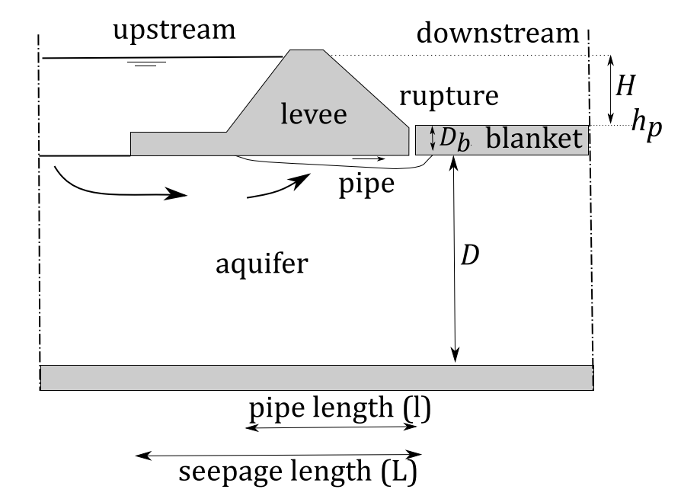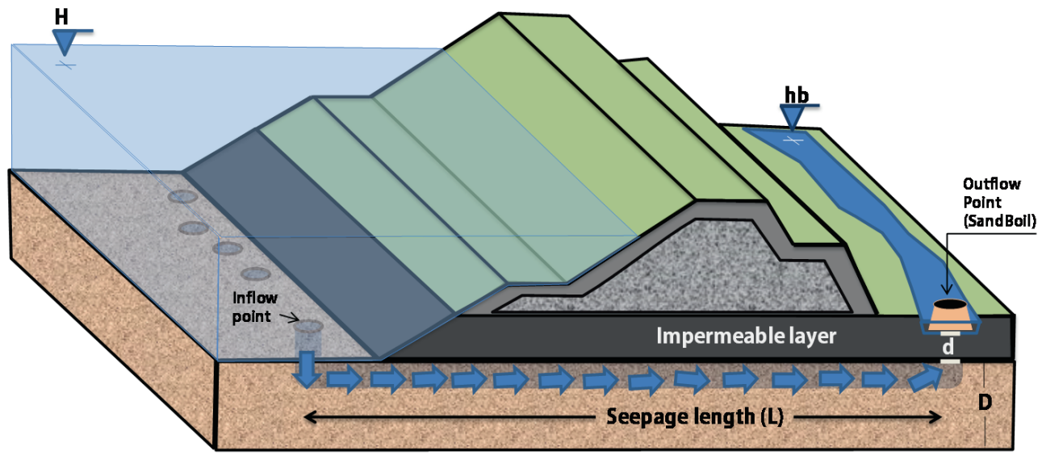

Figure - Schematic of piping erosion below a dyke (left: Pol et al., 2021; right: Aguilar-Lopez et al., 2018)

A soils seepage flow field can be modified in the field using barriers. Conventional stabilizing solutions often use direct installations such as a cut-off sheet pile wall, diaphragm wall or sheet pile barrier in the dike body. Alternative approaches include deep-soil mechanical mixing with hydraulic binders, or the placement of large masses at the toe. Such methods are deemed invasive and expensive, especially in densely populated regions throughout the Netherlands. For this reason, an innovative in-situ flow barrier which targets highly permeable soils, could become an attractive alternative solution. General study approaches for the design of engineering solutions follow empirical characterization, field assessments, research, and implementation. To include the role of external forcings, such as tides, a risk driven approach is most implemented. The responsibility of a technique’s success lies both with the assessors and technical designers (Rijkwaterstaat, 2017). For these reasons, new technologies require substantial research prior to large scale implementation.

## Sterke Lekdijk Project

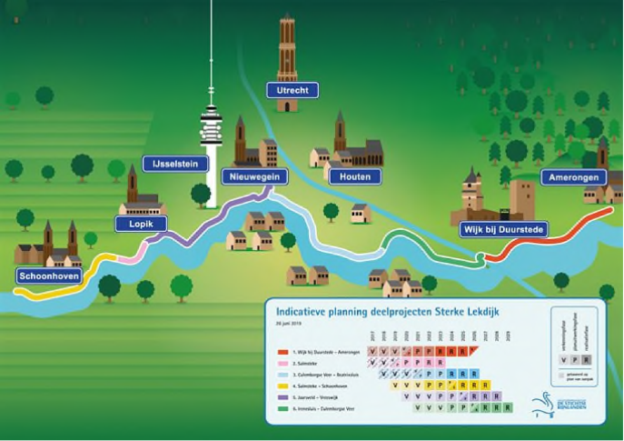The Lekdijk shelters a 55km stretch of the western Netherlands from flooding. Breakthrough of this section would lead to catastrophic flooding of the Randstad region, potentially extending until Amsterdam. For this reason, reinforcements are planned between Schoonhoven and Amerongen. Long term safety and compliance to the new 2017 standards are the driving effort by HDSR (HDSR, 2021). Out of six sub-projects selected for the strategic product innovation plan (SOP), this research targets the Wijk bij Duurstede to Amerongen (WAM) track. The primary aim of the SOP is to apply strengthen the dyke with cheaper, faster, sustainable, and spatially flexible methods. In doing so the satisfaction of stakeholders is met. Innovation and knowledge sharing drive the collaboration between HDSR, engineering firms and knowledge institutes. However, to validate innovations’ large-scale success, the focus remains on the application of innovation and its development steps. The primary focus lies on piping risk reduction (SOP 1), whereas macro stability is targeted in the second phase (SOP 2). Following an innovation scan performed by HDSR, the SoSEAL technology has been chosen as a promising semi-permeable barrier to reduce the risk of piping (primarily by seepage length extension). The development steps of SoSEAL are defined in the Ontwikkelplan defines the development steps of the SoSEAL. More precisely, the project specific design guideline targets (SS1) contain various steps: the failure path analysis SS1.1., a hydraulic conductivity model and lab verification SS1.2., a SoSEAL permeability to sand study SS1.3., design guidelines SS1.4., and verification of the latter in SS1.5. Additionally, the SoSEAL-cover connection is verified in step SS4. Lastly, the manufacturability and demonstrability will be verified in the field during steps SS3, which lies beyond the scope of the internship. The culmination of these development steps prepares the test dike implementation phase alongside the contractor, Heijmans in SS5 and SS6. The scope of the internship and the contribution to the development steps is discussed in sub-chapter *1.4*.

Figure - The Sterke Lekdijk innovation sub-projects. SoSEAL is studied in the WAM stretch to the east (red).

## SoSEAL Technology

Zhou’s (2020) doctorate research studied and proposed the “Development of a nature based geo-engineering solution to reduce soil permeability in-situ”. The inspiration is derived from natural Podzol soils, characterized by a leached topsoil and a B-soil horizon. Under specific conditions, organic matter (OM) and polyvalent metals (Fe, Al etc.) form soluble complexes. Complexes of unknown organic compounds (fulvic acid, humic acid and humin) interact by metal-ligand interaction in the soil. Cation-binding affinity of Al3+, Fe3+ and Cu2+ is predominantly controlled by the phenolic group, due to their net negative surface charge (Milne et al., 2003). Such phenomena allow for the hydrolysis of cations and thus leaching of the topsoil, whereas the solution of organo-metal complexed infiltrate highly permeable layers (Lundstrom et al., 2000). Changing environmental conditions, most notably increasing pH and cation saturation rate, lead to the precipitation solid flocs (van Hees et al., 2000; Nierop et al., 2002). Further details on the mechanistic model are beyond the scope of this work and can be found in Zhou’s (2020) PhD.

SoSEAL technology utilizes monomeric aluminum as the metal reagent, whereby the metal-ligand binding and electrostatic interactions lead to the precipitation of organo-metallic floc like structures up to 1cm in size. Aluminum ions are used due to their high binding affinity, large charge density and stability once flocculated (Zhou, 2020).

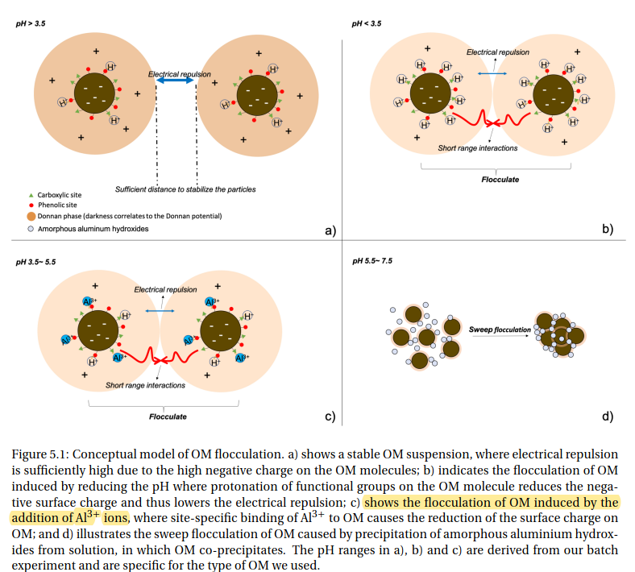

Figure - High pH (c) favors deprotonation of OM functional groups, increasing the site specific Al3+ ionic availability. At pH 5-6 aluminum outcompetes hydrogen ions to neutralize the OM surface charge. The phenolic group has a large binding affinity. Reduction of electrostatic repulsion with sufficient replacement of Al3+ leads to Flocculation.

The size of flocs correlates to the settling velocity and transport distance (filtration in a flow field). Increasing Darcyan flow velocity increases shear, allowing for suspension and transport of small colloids. They act as cloud-like aggregates, with constant particle collisions, yielding particles of 10-100µm in aquatic form. Interactions with the solid soil matrix induces mechanical filtration, where the retention of particles at the pore throat reduces hydraulic conductivity in situ. Zhou (2020) modelled the barrier reducing hydraulic conductivity of the soil by an average of 4 orders of magnitude. The shear dependency of Al-OM floc size is therefore exploited in applying the technology in-situ.

The SoSEAL semi-permeable barrier was tested in large-scale field tests, where high permeability sand layers (10-4 m/s) below the cover layer posed stability risks at high water levels. Reducing the generation of excess pore pressures in the dike body increases effective stress, allowing sufficient overburden to reduce the risk of slope slide and heaving soil failure. Ergo, the technology contributes to reducing the failure probability of the structure by altering flow rates and flow paths beneath it.

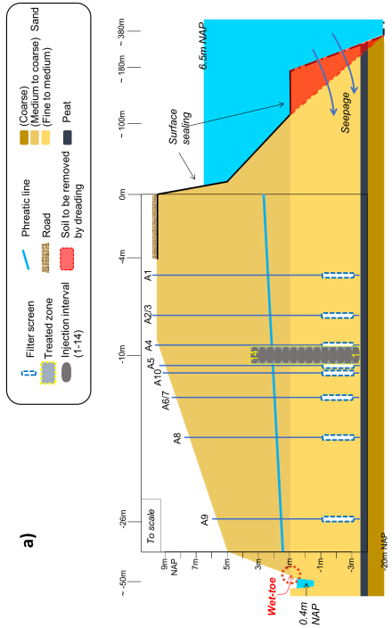

The direct floc injection method forms a continuous 70m wide and 7m tall vertical flow barrier. Due to a radius of influence of 0.5m in medium sands, 14 injection intervals (0.13m3 of Al-OM floc suspension at a rate of 60m3/d) vertically for a total of 70 injections at constant horizontal spacing. Further details regarding the implementation (eg. HA concentration) can be found in the full PhD work. Zhou (2020) stresses the sensitivity and uncertainty linked to SoSEAL continuity, especially due to the injection methods and aquifer anisotropy. Minimizing discontinuity reduces preferential flow, increasing the effectiveness of the barrier. Although showing great potential of the SoSEAL, previous research is not fully comparable to the WAM subsection, and therefore requires work from the innovation team to approve the technology in the SLD Development Plan.

## Scope and Research Targets

To contribute to the project-specific design guidelines of the SoSEAL in the WAM subsection, the scope of the internship is proposing an initial numerical study for steps SS1.2. and SS4. The implementation considers and builds upon the outcomes of the failure path analysis SS1.1, such as the inclusion of both a thick sand package and an intermediate layer scenario. Work package SS1.2. consists in developing a methodology to generate model-based calculations that will research the SoSEAL’s permeability reduction of a project-specific normative situation (archetype). The emphasis lies of modelling a realistic location based on abundant field data, used to generate a spatially variable domain. Lastly, the dimensions and reduction properties will be varied. In summary the following points will be addressed:

1. Characterize and model an archetype in the Wijk bij Duurstede – Amerongen WAM section. Aquifer heterogeneity is modelled with spatial variability as a function of subsurface data.
2. Model the thick aquifer (primary focus) and the intermediate layer scenario
3. Develop a modelling tool suitable for designing the SoSEAL barrier
4. Analyze the functioning of the semi-permeable barrier as an anti-piping measure in a spatially variable domain.
5. For the modelled archetype propose an optimized SoSEAL barrier design. The location, geometry and average reduction factors are specified.

# Theoretical Background

## Piping Theory

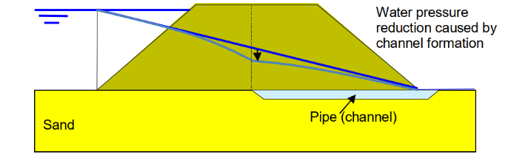Backwards erosion piping threatens water retaining structures worldwide during flood events (Danka and Zhang, 2015). Piping generally occurs when flood defenses, subjected to a large hydraulic head difference, are constructed above sandy foundations (Van Beek et al., 2015). Three factors must be met for a pipe to occur at the interface of the cover and aquifer. Firstly, uplift in the hinterland cover layer must occur, whereby the water pressure exceeds the weight of the cohesive soil. Secondly, the slurry in the crack must undergo heave, such that the sand grains are transported vertically and removed from the cover-sand interface. Thirdly, piping erosion may occur when sufficient seepage erodes a pipe below the dike (HDSR, 2017). Such channel acts as a drain towards the rupture, whereby sufficient drag forces by rapid flow induce the rolling of grains. This erosion mechanism lengthens the pipe in the upstream direction (*Figure 5*, primary erosion). Widening of the channel occurs once the pipe reaches the upstream side, with propagation of a wider and deeper channel towards the downstream exfiltration zone (secondary erosion) (Van Beek et al., 2010). Deformation of the downstream slope occurs thereafter, leading to dike failure (Pol et al., 2021).

Figure - Retrograde erosion of the pipe channel leads to a localized increase in gradient between the pipe head and water side (H). Gradient dissipation leads to fast flow and sand transport in the pipe. (Van Beek et al., 2010)

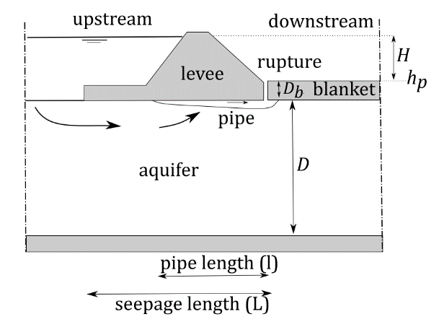Semi-theoretical models can be used to predict piping in the sand body below a dyke. The most basic formulations of piping equate the critical head (external load) over the shortest seepage length to the geometry and soil dependent erosion coefficient (rollover resistance). Equilibrium below the dyke is a function of the pipe length (*l*) versus the head at which grains maintains equilibrium (*Heq*). Exceedingly large loading leads to the critical level at which grains lose equilibrium, which is defined as the upstream water level critical head *Hc* (Van Beek et al., 2015). The progressive phase is defined by Pol et al. (2021) as the critical head afterwhich pipe growth continues given a constant head. The associated critical pipe length (*lc*) defines the limit after which progression dominates, and propagation continues below the dike. Equilibrium can only be re-achieved by drastically lowering the head upstream.

Figure - Schematic of piping erosion below a dike (Pol et al., 2021)

The resistance to erosion is dependent on the physical properties of the sand layer and seepage length. Empirical rules such as Lane (1935), Bligh (1910) and Sellmeijer (1989) only address the third piping factor: grain equilibrium. The first two formulations (*Annex* *10.4.3*) are limit state equations calibrated to d50 and seepage lengths of large dam safety assessments. Later developments of limit state equations by Sellmeijer include multivariate analyses of grain specific variables (*Annex* *10.4.2*). These approaches all indicate a potential for piping erosion failure at Wijk bij Duurstede – DP 103 (*Annex 10.4 Empirical Piping Criteria*) but are unsatisfactory in predicting the role of embedded infrastructure and subsurface anisotropy. In fact, recent modelling developments, reflected in the improved safety standards, call for improved quantification of the phenomena (HDSR, 2017).

## Piping Modelling

### Current Practice

Empirical formulations have been used in the past to quantify piping susceptibility in the Netherlands (Lane, 1910; Bligh, 1935, Sellmeijer; 1989). Using such methods yields both safe and unsafe results at the WAM dyke stretch (see *Appendix* *10.4 Empirical Piping Criteria*), in function of the foreland seepage path. Furthermore, these methods were developed without considering the role of embedded structures, which are known to alter aquifer flow. Ergo, they are unsatisfactory in answering the *1.4 Scope and Research Targets.*  
Recent developments in numerical methods propose various approaches in modelling the complex piping erosion phenomena. Most models and experiments assume a cover layer failure, and that heave in the vertical channel can always occur, focusing rather on modelling the horizontal piping erosion process (Sellmeijer et al., 2011; Van Beek et al., 2014; etc.). Increasingly precise information is available in large-scale experiments (Van Beek et al., 2010; Pol et al; 2021). Some approaches model meandering of the pipe along the summit of the aquifer in a 2D domain (Rotunno et al., 2018), whereas others simplify the problem in one dimension (Aguilar-Lopez et al., 2016). Both approaches assume a perfectly horizontal propagation along the cover-aquifer interface. For example, piping erosion models ranges from multi-phase flow (turbulent fluid flow in the pipe versus seepage in the soil, coupled by mass conservation equations) in one dimension (Lachouette et al., 2008) to one phase flow using equivalent hydraulic conductivities (Bersan et al., 2013). Therefore, the complexity, simplifying assumptions and uncertainty range considerably.

In the Netherlands, piping specialists at Deltares have developed the D-Geo flow program, which models iteratively the potential development of a pipe. Conservation of mass and generalized Darcyan flow (source terms) are coupled to the commonly used Sellmeijer formulation of Poiseuille flow two-force grain limit equilibrium (sink term). The pipe is created and enlarged by increasing the hydraulic diameter (*a*). The pressure gradients in the modelled pipe (*dh/dx*) are compared to Sellmeijer’s sand grain equilibrium criteria (dark blue line, *Figure 7*). To guarantee piping prevention all lines must be situated below the Sellmeijer line.  
The program operates by iterations which ‘construct’ and backcheck the erosion channel through a series of blocks, starting from the cracked cover layer. Iteratively attributed geometries of rectangular pipe domains of fixed width are constructed. As an example, the process for the first two rectangles is shown in *Figure 7*. Commencing from no pipe, the first iteration progressively opens one pipe element. The pressure gradients of this iteration are shown in *Figure 7* - step (a). In this case, piping erosion can occur since the channel hydraulic gradient (red line *dh/dx*) lies above Sellmeijer for a hydraulic diameter between *athreshold* to *aequilibrium*. The first element is thus assumed to erode.Progression of the pipe is checked in the next iteration, shown in *Figure 7* - step (b). In this case the hydraulic gradient of the second element (light blue *dh/dx*) does not exceed Sellmeijer. Therefore, piping erosion cannot occur, and the channel is ‘stabilized’.

Figure - Element activation iterative process, in dark blue Sellmeijer’s grain equilibrium criteria. The first element is scanned in **step (a)**, where increasing the channel height yields pressure gradients (red line) greater than the limit for grain equilibrium. Piping erosion can occur. Element one is ‘opened’ since piping erosion can occur, after which a second is constructed upstream. The second element is scanned in **step (b)**, for which erosion will never commence due to insufficient pressure gradients (blue line) across the element.  
More specifically, the steps are further detailed as (a.1), (a.2) and (b.3):

1. *Opening Pipe Element 1, step (a.1): Starting from a rectangular element of fixed width and zero height, the channel is 'opened' progressively by increasing the hydraulic conduit height a(mm). In the first scanning step (a), a sufficient pressure gradient is reached for the minimum activation of the pipe element. Rolling of grains is assumed to occur from athreshold(mm) onwards, and piping erosion will occur in this element.*
2. *Fixing Height of Pipe Rectangle 1, step (a.2): To fix the element’s size in 1D, the height of the channel a(mm) is increased. Continued larger hydraulic diameters decrease the drag force on grains, reaching equilibrium of the erosion channel at a height of ~1.8(mm). Once the element reaches this state, the channel is stable. The element is associated a domain height of aequilibrium(mm).*
3. *Pipe Domain 2, step (b.3): The iteration moves upstream creating the next adjacent rectangular element. While increasing the channels height, the pressure gradients are not sufficient to exceed Sellmeijer (light blue line lies below the dark blue line, for any hydraulic diameter). The rollover of grains in a horizontal channel cannot occur and the pipe stops.*

This implementation has its limitations when studying the internships *1.4 Scope* a*nd Research Targets.* It may address well the piping erosion phenomena as per current practice in the Netherlands (Scope 4) and an intermediate layer scenario (Scope 2). However, it cannot be used to evaluate the role of spatially variable domains (Scope 1), design the SoSEAL (Scope 3), and propose an optimized barrier for the modelled archetype (Scope 5).

### Modelling Strategy

The challenge of modelling a complex and uncertain process such piping erosion, is paralleled by the project-specific need to quantify the role of an embedded structure in a spatially variable domain. To meet the study’s objectives *(3.4 Scope)*, it is necessary simplify the modelled problem. Oil and gas research have simplified preferential pathway flow by resolving the Navier-Stokes equations under parallel-plate and laminar flow assumptions (Gassem et al., 2020). This approach is often referred to as the ‘cubic law’, which relates the hydraulic aperture of a fracture and its permeability (Ranjith and Viete, 2011). One existing piping erosion research approach models the pipe using a cubic law, by assuming the pipe channel to be filled with a highly permeable material K* (Bersan et al., 2013; Van Been et al., 2014; Aguilar-Lopez et al., 2016). The model is therefore non-iterative and contains only the Darcyan flow phase, which increases computational efficiency and eases implementation (Aguilar-Lopez et al. 2018). Bersan et al. (2013) have shown the approach to yield comparable results to the fully coupled Darcy-Brinkman and Navier-Stokes numerical solution both in 2D and 3D. Additionally, Wang et al. (2014) has used a similar approach to simulate an iterative pipe progression model containing a sheet-pile.

The model focuses primarily on piping erosion, proposing a steady-state condition by predefining a horizontal erosion channel of constant height (defined as per the hydraulic diameter *a=ng*d70*, where *ng* is a channel height geometry factor and *d70* the 70% percentile grainsize) and back-checking its state. Channel pressure gradients are computed in the Darcyan FEM by assigning the ‘cubic law’ fictive permeability (K*) to the pipe domain. The grain equilibrium or lack thereof, is checked by comparing the channel gradients to the limit equilibrium of grains according to the two-force approach (Sellmeijer et al., 2011).

*Load Term (S): Cubic Law*The pressure gradient in the predefined erosion channel (${\frac{∂P}{∂x}}_{FEM}$) is resolved by Darcyan flow in the steady-state FEM. In porous media, fluid flow is typically governed by Darcy’s law of specific discharge through a unit area:

$$u=\frac{κ}{µ}ρg∇H$$

The vector describing flow rate *u* is a function of the *κ* permeability of the porous media, viscosity *µ* and unit weight *ρ* of the fluid, acceleration of gravity *g*, and the gradient of hydraulic head *H*.

Assuming one-dimensional laminar flow, no-slip condition at the walls, and null perpendicular velocity tensors along the pipe wall, the pipe can be modelled as a Hagen-Poiseuille flow. In a closed conduit of hydraulic diameter (*Dh*), the head loss corresponding to a pressure gradient is given by the Darcy-Weisbach equation (Mott et al., 2006), the flow friction factor *f* (Muzychka and Yovanovich, 2009) and Reynolds number *Re*:

$$∇H=\frac{fu^{2}}{2ga}, f=\frac{β_{fi}}{Re}, Re=\frac{uρa}{μ}$$

Where the *βfi* factor depends on the cross-section shape, *u* the velocity, and viscosity *µ* and unit weight *ρ* of the fluid. Resolving for the average velocity across the cross section, the expression becomes the Hagen-Poiseuille flow equation for tubes of a general shape:

$$u= -\frac{2a^{2}}{β_{fi}}ρg∇H$$

By comparing it to Darcy’s law, it can be concluded that under the assumptions of saturated, fully developed laminar and incompressible flow in a pipe, a high porosity material can be represented by an equivalent hydraulic conductivity K* (Bersan et al., 2013; Aguilar-Lopez et al., 2018):

$$K^{*}=-\frac{2a^{2}}{β_{fi}}$$

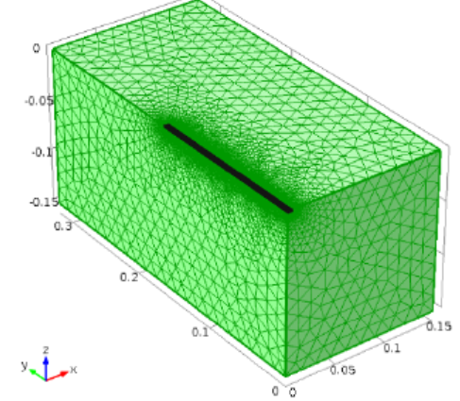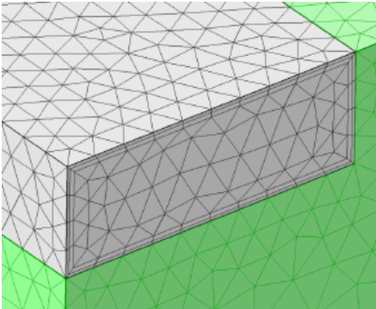

Figure – (Left) Black pipe domain modelled in 3D using Darcy’s law COMSOL interface, with scale-specific refined meshing around the channel. (Right) The gray pipe is attributed a hydraulic conductivity of K* (Bersan et al., 2013)

The FEM utilizes Darcy’s law to compute the steady state pressure head distribution over the entire model geometry. Finally, the load term ${\frac{∂P}{∂x}}_{FEM}$ is computed inside the pipe domain by a linear approximation (for more details see *Annex* *10.2 Linear Approximation*).

*Resistance Term (R): Two-Force Equilibrium*The pressure gradient by which horizontal drag forces are sufficient to erode the sand grains is defined by Sellmeijer’s criteria (${\frac{∂P}{∂x}}_{crit}$). The approach uses a single particle approach, for which transport occurs by rolling under force disequilibrium. Two non negligeable forces are considered: the vertical weight of the particle, and the horizontal drag force due to channel flow (Sellmeijer et al., 2011). The horizontal and vertical seepage gradients are expected to be negligeable in the equilibrium calculation (Van Esch, 2014). Assuming a sufficiently shallow erosion channels under laminar flow, the Navier-Stokes solution of pipe flow expresses the shear stress at the bottom of the channel as:

$$τ=\frac{1}{2}γ_{w}pa$$

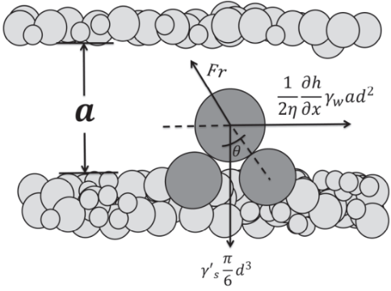The drag force is expressed as the uptake of shear stress of single grain in a sand bed by Whites constant *η*=0.25 (Van Esch, 2014; Deltares, 2020), as the product between basal shear stress and equivalent grain area contact (Sellmeijer et al., 2011):

$$F_{drag}=\left(\frac{1}{2}γ_{w}pa\right)*\left(\frac{d^{2}}{η}\right)$$

The self-weight force for a circular grain is simply the product of unit weight and volume:

$$F_{weight}= γ_{s}^{'}\frac{π}{6}d^{3}$$

The sine law resolution of the two-force equilibrium, shown in *Figure 9*, can be expressed as:

Figure - Schematization of the two-force equilibrium condition inside an eroding pipe, as function of channel height a=ng*d70 (Aguilar-Lopez et al., 2016)

$$\frac{\left(\frac{1}{2}γ_{w}pa\right)*\left(\frac{d^{2}}{η}\right)}{sin⁡(θ+α)}=\frac{γ_{s}^{'}\frac{π}{6}d^{3}}{cos⁡(θ)}$$

In continuation, the limit horizontal pressure gradient before grain rolling onsets is a function of the channel height (*a*). Simplifying and discretizing a pressure gradient in one dimension for a horizontal (Van Esch et al., 2014) and inclined channel (Sellmeijer et al., 2011):

$${\frac{∂P}{∂x}}_{crit,horiz}= \frac{π}{3}\frac{γ_{s}^{'}}{γ_{w}}\frac{d_{70}η}{a}tan⁡(θ) {\frac{∂P}{∂x}}_{crit, sloped}= \frac{π}{3}\frac{γ_{s}^{'}}{γ_{w}}\frac{d_{70}η}{a}\frac{sin⁡(θ+α)}{\cos\left(θ\right)}$$

Where the rolling angle of sand grains *θ*, the grainsize *d70*, the effective unit weight of the solid *γs’*, Whites constant *η* are input parameters.

# Study Location

The aim of this research is to explore the effect of the SoSEAL barrier on the seepage flow field modification in the WAM Lekdijk stretch. Primary focus is brought to the design of the barrier, aiming to push for its project specific implementation in SS5-SS6. In a preliminary sensitivity analysis HDSR has located key locations prone to piping risk. Most notably, a thin cover layer and a waterway in the hinterland characterize the most vulnerable areas. Furthermore, by excluding those with a long foreland, dike piles DP105-85 and DP20-40 were selected alongside geo-technical engineers working for CRUX as suitable archetypes for the initial model in line with the research’s scope.

## Representative Archetype – DP103

Dike pile 103 is chosen as the representative cross section, upon which the location specific flow field characterization and SoSEAL design will take place. As seen in *Figure 10*, Wijk bij Duurstede lies closely downstream of the critical zone. Existing infrastructure, such as tennis field, call for non-invasive and space efficient piping risk minimizing solutions. As discussed in *3.2 Sterke Lekdijk Project*, the SoSEAL provide a viable solution for such location. Furthermore, abundant data is available to characterize the subsurface, aiming to reduce the sources of uncertainty in the model development.

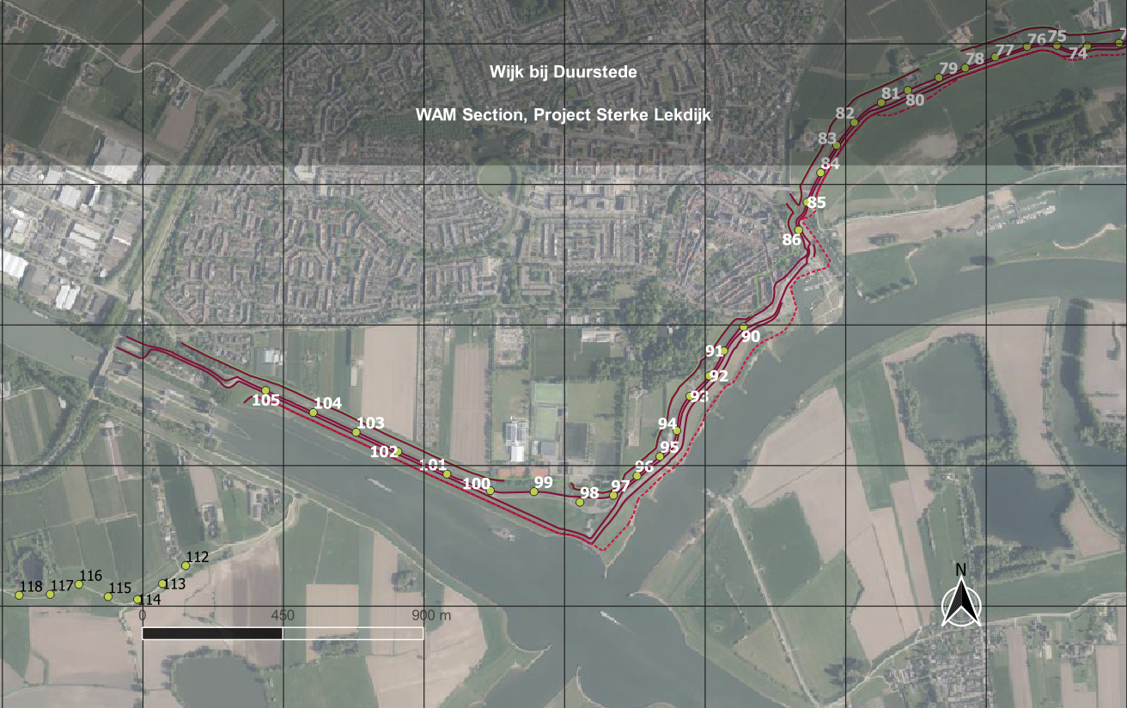

Figure - Location vulnerable to piping, most notably between DP105-100 and DP96-86, located at the western end of the Lekdijk WAM stretch.

The study location characterization is organized as a function of the geometry, subsurface data and the hydraulic characterizations.

## Geometry

Bathymetry and topographical data are precisely measured for the DP103 archetype. The field exploration data is kindly provided by Silvia Bersan (CRUX). Such measurements provide precise coordinates to map the field geometry in the finite element model. Certain features, such as the foreland extension of the cover layer and the depth of the waterway, are key factors controlling the seepage flow.

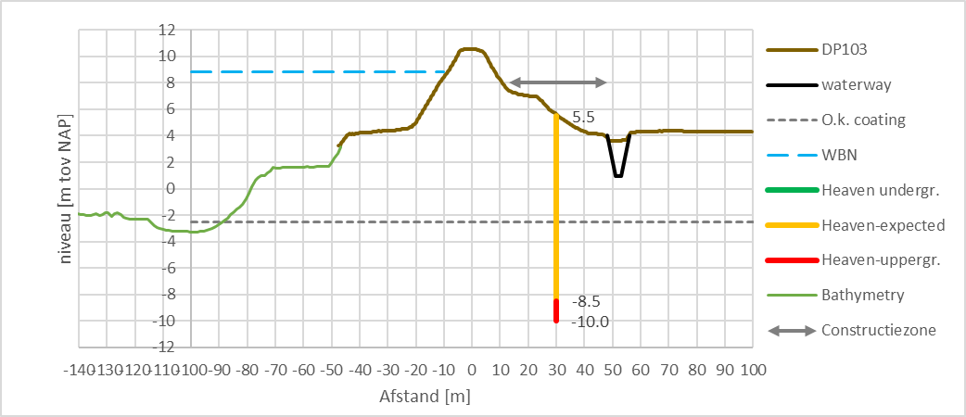

Figure - Geometry of dike pile 103 according to bathymetry and altimetry data, supplied by Bersan of CRUX. In orange and red a proposed classical sheet pile installation to increase the seepage length.

## Subsurface Data

According to Bersan (CRUX, 2022), the project design characterizes the study location using a two layered lithological simplification of the cover layer (*located* *above the gray dotted line, Figure 11*). The basal 4[m] cover is characterized by γc1=16.5 [kPa], whereas the somital 4[m] cover is characterized by γc2=18 [kPa].

### CPT’s and Boreholes

The lithological profiles performed across the WAM are constructed using shallow boreholes (<10m) and CPT’s (~25m). As shown in the georeferenced *Figure 12*, cross-section data points are located at the waterside (BUB), the dyke summit (KR), and two inland locations (BIB and BIT). The parallel cross sections are generated from 2018 and 2021 CPT and borehole data spaced evenly every ~75m.

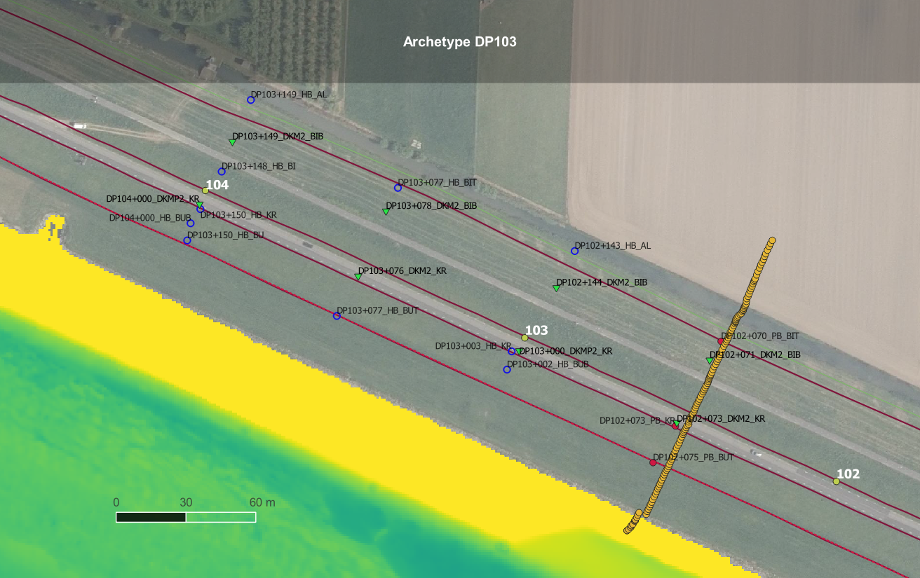

Figure - Georeferenced data characterizing the WAM subsurface. Yellow filled markers represent the dike pile location, green triangles CPT measurements, blue/red circles boreholes, and the orange points are altimetry data points. Note the absence of deep data in the riverbed and the fields inland.

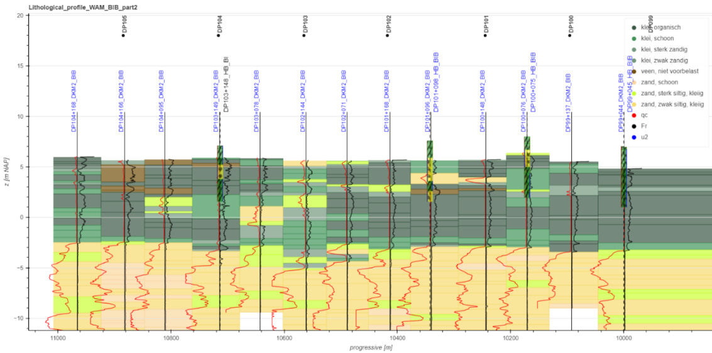

Figure - Lithological cross section parallel to the dyke stretch, in this case ranging from DP105 until DP99. As seen the Wijk bij Duurstede location is characterized by a semi homogeneous cover layer (green-gray clays with varying sand and organic content) and thick aquifer (beige-yellow sands with varying silt). The CPT’s show continuous sand at least until -20m NAP.

Two simplified lithologies are approximated from the 2021 Lithological Profiles WAM, and deep soundings. The cover layer is simplified as a homogeneous clay with sand, containing organic matter. The deep sand aquifer is continuous (sounding indicate >30m depth) but marked by vertical spatial variability akin to Pleistocene sands. Stemming from the SLD project specific design value of 30[m], a pessimistic assumption is made for the aquifer depth by applying a safety factor γ=1.1, such that the model uses an aquifer of 34[m].

### Grain Sizes and Kozeny-Carman

Due to the regional distribution of pumping tests, grainsize data and aquifer flow in proximity of Wijk bij Duurstede is a critical parameter to calibrate for the FEM model. Two expeditions are performed retrieving grainsize data. Sampling at the target location has therefore been performed eight times in a <1km radius around DP103. The following grainsizes are quantified from the available particle distribution curves. Chapuis (2012) has shown the large suitability of applying the Kozeny-Carman equation to predict a soil’s hydraulic conductivity as a function of particle diameters. Its use is also common in piping erosion stochastic simulations (Aguilar-Lopez et al., 2016, Mazzoleni et al., 2014). Furthermore, Vukovic and Soro (1992) formulated an empirical relationship to calculate porosity as a ratio of particle diameters.

$$K= \frac{ρg}{μ}\frac{n^{3}}{{\left(1-n\right)}^{2}}\frac{d_{70}^{2}}{180} n=0.255(1+{0.83}^{\frac{D_{60}}{D_{10}}})$$

With:

*K [m/s] Hydraulic conductivity  
ρ [kg/m3] Water density  
g [m/s2] Gravity  
µ [Pa*s] Dynamic Viscosity 10°C  
n [-] Porosity  
d70 [m] Representative diameter*

Table - Grainsize data, retrieved from the vicinity of DP103.

|  |  |  |  |  |  |  |  |
| --- | --- | --- | --- | --- | --- | --- | --- |
| **Name** | **Depth** | **d10** [µm] | **d50** [µm] | **d60** [µm] | **d70** [µm] | **n** [-] | **KK-C** [m/s] |
| *DP102+070 BIP* | 8.8 – 9.1 m mv | 215 | 400 | 480 | 580 | 0.423 | 33.26 |
| *DP102+070 BIP* | 8.6 – 8.7 m mv | 240 | 483 | 510 | 600 | 0.427 | 34.04 |
| *DP102+070 BIP* | 10.8 – 11.1 m mv | 230 | 456 | 600 | 750 | 0.412 | 30.67 |
| *DP102+070 BIT* | -3.96 – 4.12 m NAP | 146 | 246 | 270 | **296** | 0.436 | **36.26** |
| *DP102+070 BIT* | -4.26 – -4.39 m NAP | 145 | 242 | 268 | **300** | 0.436 | **36.26** |
| *DP102+070 BIT* | -6.66 – -7.01 m NAP | 182 | 324 | 377 | 455 | 0.428 | 34.47 |
| *DP102+143 HB AL* | -2.3 - -3.0 m NAP | 4 | 105 | 134 | 165 | 0.256 | 7.32 |
| *DP104+168 HB AL* | -2.6- -3.3 m NAP | 4 | 201 | 229 | 260 | 0.255 | 7.27 |

In porous media, it can be noted that the particle size dominates the intrinsic permeability, thus affecting the hydraulic conductivity of a porous media. Additionally, the correlation between d70 and K isn’t constant for all quantiles, but rather shows tail dependency (Aguilar-Lopez et al., 2016). This fraction is also most prone to piping erosion due to decreased rolling resistance of small grains. Lastly, the piping erosion process mainly targets the somital section of the aquifer, which is appropriate for the sampling locations highlighted in blue (*Table 1*). Ergo, the model input d70 is set to 296µm.

## Hydrological Characterization

### Aquifer Hydraulic Conductivity

Hydrogeological groundwater studies were conducted between Wijk bij Duursteded and Amerongen (WAM). The data distribution is sparse, but indirectly quantifies the heterogeneity of the Pleistocene sand aquifer. Inpijn-Blokpoel and Wiertsema conducted the “Uitwerking Pompproef” in 2018 (see *Annex 10.1.1*). In-situ Pumping tests yield rather conservative values ranging from 1.1 - 50.7 [m/d] along the WAM section, whereas HPT calculations of hydraulic conductivity yield ranges 2.2 – 69.9 [m/d]. These values concur with the Kozeny-Carman calculations as a function of in-situ grain sizes (*Table 1*).  
The project development is designed in accordance with a mean of 50 [m/d] and a maxima of 70 [m/d]. Ergo, assigning a 95% confidence value to the maxima derived from pumping tests, the variability will be modelled using a standard deviation of 10 [m/d]. Such values concur both with in-situ tests, Kozeny-Carman calculations and HPT tests. *Table 2* shows the input values for the seepage flow model.

Table - Aquifer large scale pumping test mean and standard deviation (blue), compared to the maximum hydraulic conductivity calculated using the Kozeny-Carman formulation (from Table 1)

|  |  |  |  |
| --- | --- | --- | --- |
|  | **KK-C, max** [m/d] | **Kµ,aquifer** [m/d] | **Kσ,aquifer** [m/d] |
| *Pessimistic* | 36.29 | **50.0** | **10.0** |

### 

### Lek River Water Levels

The historic Lek river water levels are extracted from the water base of Rijkswaterstaat. The “maatgevende hoogtes” from Amerongen between 1995-2022 were treated, yielding the following worst-case scenarios to which the dyke may undergo. Ergo, the data is segmented into percentiles to extract the desired confidence. Additionally, the thousand-year return value is provided in *Table 3*, which is selected as the model boundary condition.

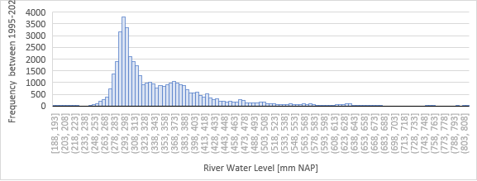

Figure - Cumulative distribution of river water levels heights with respect to NAP between 1995-2022. High levels are rare, with >600mm water levels occurring with very low frequency in history.

Table - River water level quantiles from historical data, in blue to pessimistic selected river head used in the model.

|  |  |  |  |  |  |
| --- | --- | --- | --- | --- | --- |
| **Location** | **Median** | **95%** (2σ) | **99.7%** (3σ) | **Maxima** | **1000 Yr Return** |
| *Amerongen (hriver)* | +3.21 m NAP | +5.08 m NAP | +7.69 m NAP | +8.12 m NAP | +**8.82** m NAP |

# Model Design

This research aims to build a seepage and deterministic piping erosion FEM model of the Wijk bij Duurstede large-scale dike. Additionally, parameters must be modifiable to design and quantify the impact of the SoSEAL barrier. More specifically, the model must compute the location specific seepage effects due to an embedded structure, include spatial variability (whereby the background Ksat,aquifer defines the KSoSEAL) and an advanced scale dependent meshing system (addressing the discrepancy of a millimetric pipe in a hectometer flow domain).

## Governing Equation

The intrinsic properties of a soil and the fluid’s physical properties dictate the hydraulic conductivity of porous media. For example, a low viscosity fluid in a highly permeable medium will be characterized by fast flow. The hydraulic conductivity can be defined as:

$$K= \frac{k*ρ*g}{µ}=\frac{k*γ_{w}}{µ} in [m/s]$$

Where *k [m2]* is the intrinsic permeability, *ρ [kg/m3]* density of the fluid, *g [m/s2]* gravity, the dynamic viscosity *µ [Ns/m2]*. In the case of water as a fluid (assuming constant temperature and thus constant viscosity), the flow is controlled by the physical properties of the porous medium (intrinsic permeability). Although beyond the scope of the research, the intrinsic permeability can be expressed by Kozeny-Carman’s formulations as a function of the tortuosity *c [-]*, the particle diameter *d [m2]* and the porosity *n [-].*

In in a hydrostatic system, the flow and thus transport can only occur with a gradient induced by a matric potential (gravimetric gradient =1). In other words, the total head equals the pressure head (due to isotropic water pressure) plus the elevation head.

$$q=-K(ψ_{m})[\frac{∂ψ_{m}}{∂z}+\frac{∂ψ_{g}}{∂z}]$$

In transient flow conditions, to account for the difference in ∆qin-out we address the storage of water in the column using a form of the time dependent continuity equation.

$$\frac{∂θ}{∂t}=-\frac{∂q}{∂z}$$

Ergo, the governing equation of water movement in a soil combines steady state flow and the continuity equation. The result is Richard’s equation, applicable for unsaturated flow conditions.

$$\frac{∂θ}{∂t}= \frac{∂}{∂z}[K(ψ_{m})[\frac{∂ψ_{m}}{∂z}+1]]$$

Alternatively, if the medium is saturated, the hydraulic conductivity is constant. The governing equation is simplified to Darcy’s law as the total hydraulic head difference *dh [m]* over a length *dl [m]*, allowing the calculation of the specific discharge *q*. Assuming laminar, non-turbulent flow (Reynolds number less than 2100 (Rehm et al., 2008)) and non-viscous flow, the steady state equilibrium is resolved from the boundary conditions as:

$$q=-K\frac{dh}{dl}=\frac{k*γ_{w}}{µ}\frac{dh}{dl} in [m/s]$$

The governing equations hold true on the following basic assumptions:

1. Flow occurs in a fully saturated and incompressible porous medium.
2. Hydro-mechanical coupling is not considered. Two domains are simplified: Firstly, the slurry in a cracked cover layer isn’t modelled, but rather remains a fixed polder level boundary condition. Secondly, the pipe domain is not modelled as a multi-phase domain with eroding particles, but rather represented as a highly permeable material.

## Numerical method

COMSOL was chosen as highly advanced software capable of porous media flow modelling. The proposed FEM quantifies the susceptibility to piping erosion using two-force grain equilibrium criteria; like piping specific programs such as D-Geo Flow (Deltares, 2020). The cubic law is used to attribute a permeability to the pipe domain (Bersan et al., 2013), and Darcyan flow is resolved over the entire geometry.

COMSOL utilizes triangular or quadrilateral elements in the numerical finite element method. Additional inclusions of the Multiphysics package are the finite volume method, boundary element method and others. Quadratic elements could be used for similar results, but due to the static non-deforming model domain with sloped geometrical features, triangular elements are chosen for computational simplicity. The high aspect ratio of a modelled large-scale problem requires extremely precise meshing, dependent on the physical processes occurring locally, ergo the element sizes are automatically meshed (reaching <500µm in the conduit’s vicinity).  
A stationary solver is chosen, used to analyze the steady state condition reached once the cover layer has cracked. The simplified model does not account for hydro-mechanical coupling in primary and secondary pipe erosion, but rather shows the resulting seepage flow due to the depressurization at the crack drainage location.  
To achieve a monotonically convergent solution, the polynomials chosen as approximation functions must: have a continuous behaviour, be compatible along node or boundaries of adjacent elements, be complete permitting rigid body motion of elements, and geometrically isotropic (Fundamentals of Discretization, 2006). Quadratic interpolation in triangles and quadrilateral elements in two-dimensional equal order velocity-pressure elements yield smooth solutions in convergence tests under continuous velocities and continuous/discontinuous pressures (Masud and Hughes, 2002). This is due to the dominant second derivative term in Darcy’s flow. Similarly, Richard’s equation abides by the same discretization requirements, while adding a storage and water retention model. Ergo, the Lagrange quadratic interpolation is chosen as the appropriate fluid flow 2nd order interpolation method in the free triangular mesh.

## Cross Section and Boundary Conditions

All data presented in chapter *3. Study Location* is used to generate a representative cross section of the archetype DP103. A first order approximation of the cover-sand boundary is done by linear interpolation between CPT and borehole datapoints.  
The geometry controls cover layer thickness, aquifer depth, crack length and dyke shape. Seepage field computation is directly affected by the different resistive pathways to flow, such as in the foreland, while being unrestricted in the deep aquifer. Special attention must be brought to the models’ scale variations; piping develops in centimeter scale, the SoSEAL semi-permeable barrier scale and connection in decimeters, while the horizontal interpolations are done over several decameters.

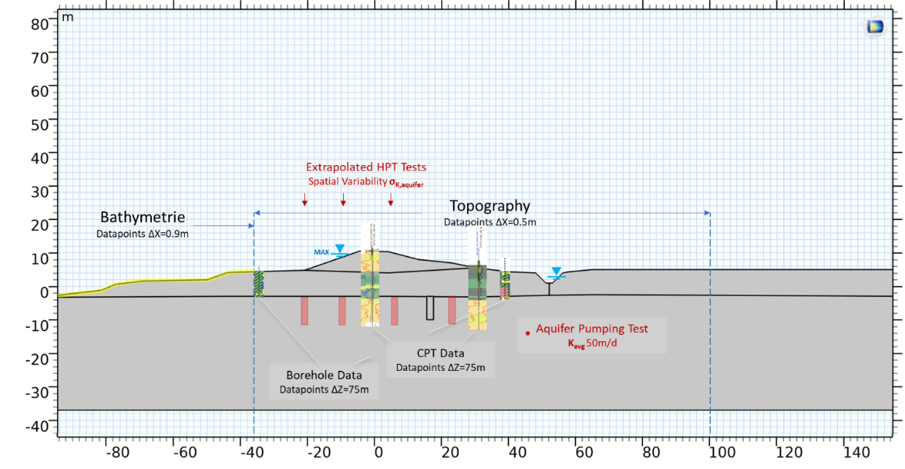

Figure - Model input merging the data summarized in subsections 3.1 to 3.5, defining the cover layer and aquifer, along with the water levels.

The boundary conditions applied to the domain are illustrated in *Figure 16.* The constant head condition at the rightmost linear bound avoids boundary effects in the distal region, and the crack radius is taken as a same order of magnitude as large-scale experiments using a diameter of 13[mm] by Pol et al. (2021):

* Upstream hydraulic head Hriver = +8.82m N.A.P. (*see 0*)
* Polder hydraulic head Hinland = +3.5m N.A.P. (*see 0.*)
* Depth of sandy aquifer = 35 [m] (*see* *245.3.1*)
* No flow at the dike summit and base of the aquifer
* Crack radius = 20 [mm] (*extremely sensitive assumption(!)*)

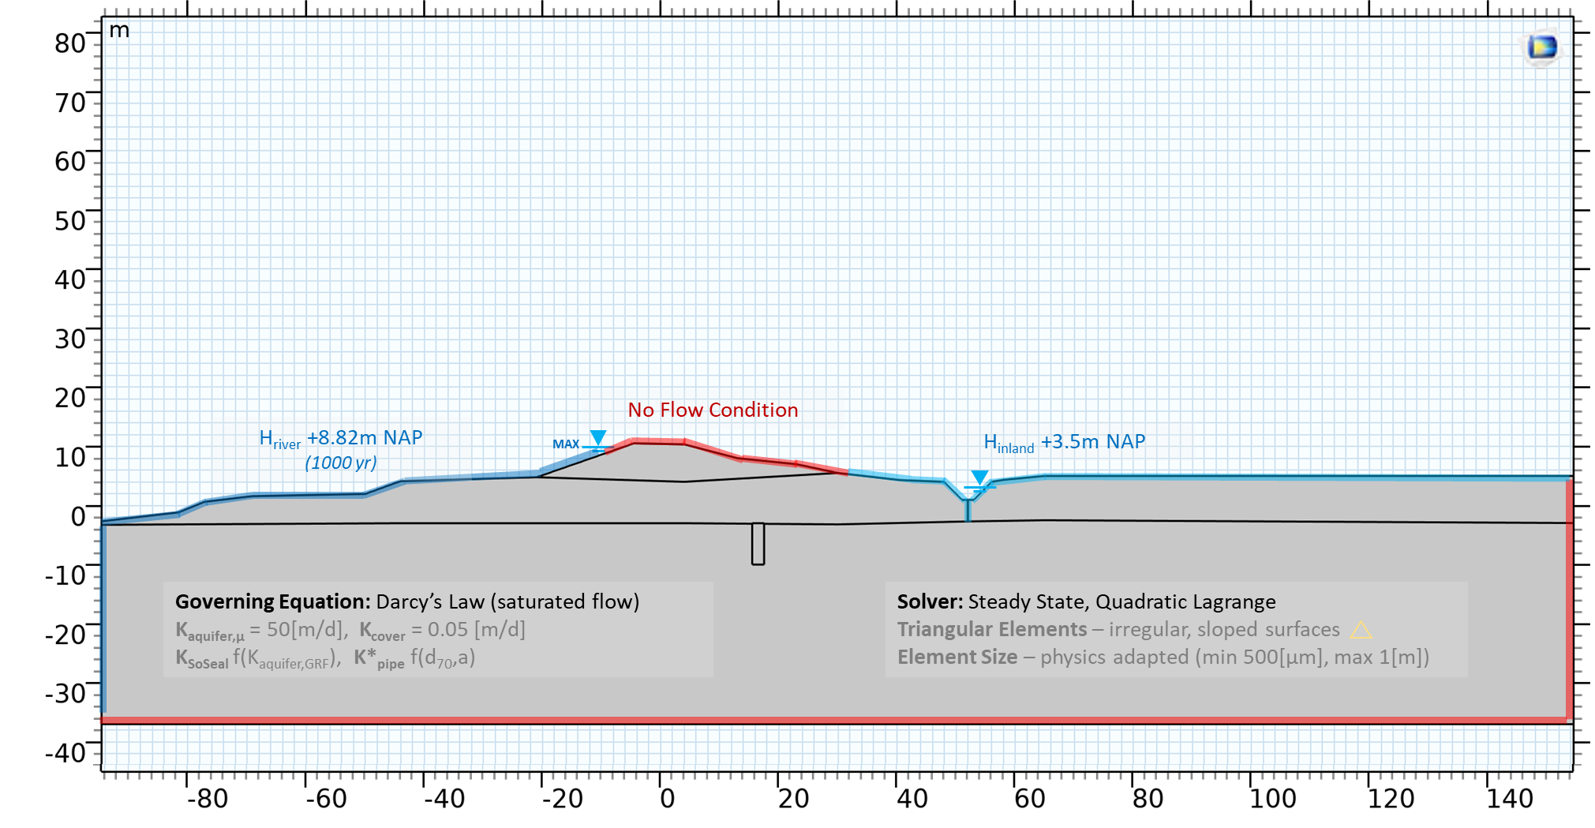

Figure - Boundary conditions and solver configuration for the FEM of DP103.

## Spatial Variability

Field data is abundant at the regional scale, but with CPT investigations cross sectioning the dyke every ~75m, substantial uncertainty is introduced in the computation of a seepage field at the local scale. The analysis of an uncertain stratigraphic medium can be tackled by random field theories. The spectral representation method yields efficient random Gaussian fields, using a known correlation function or power spectrum (Rass et al., 2019). Implemented in MATLAB, the data is exported as coordinate-specific text files. Additionally, past research (for example Ahmed and Bazaara (2009), Hoeksema and Kitanidis (1985)) has shown that free surface seepage in dykes is subjected to lognormally distributed hydraulic conductivity. To construct a layered random field of Ksat values, the nodes in the FEM mesh must be interlinked by a covariance matrix as function of the distance separating them. This is defined by point statistics of the subsurface.

Random fields can be used to model univariate spatial variability of soil properties, such as Ksat in Darcy’s flow governing equation. Input spatial (vertical θV and horizontal θH scale of fluctuation) and point statistics (mean µK, standard deviation σK), can be used to generate a layered aquifer system.

Point statistics input parameters are generated by the following field tests:

* **µK** – mean pumping test in the sandy aquifer at the regional scale, yielding a Ksat of 50 [m/d], coherent with approximations of KKozeny-Carman as a function of grainsizes (*see 5.3.2*).
* **σK** – standard deviation derived from the maximal pumping test recorded at the regional scale, yielding a Ksat,max of 70 [m/d]. Assuming a 95% confidence interval, the maximal value represents the mean plus two standard deviations. Ergo, one standard deviation is taken as 10 [m/d].

Spatial statistics input parameters are dictated by the following field tests:

* **θV** – HPT and CPT measurements are used to derive the vertical scale of fluctuation along the archetype profiles. Two to three 1D datasets per dyke profile (DP103 and DP19) are available. The high resolution along the y-axis shows variability in the ∆y=0.5-1m range.
* **θH** – Horizontal variability is most uncertain. 2D Model: Two CPT profiles (max depth -10m NAP) are located at the crown of the dyke and inland, separated by ∆x=25m. 3D Model: exploration profiles of shallow boreholes and CPT’s are completed with an average spacing of ∆z=75m.

### Aquifer Hydraulic Conductivity

Most commercial finite element software lacks the potential to generate and/or import random fields, rather relying on isotropic geometries comprised of different vertical and horizontal Ksat tensors. A stochastic approach is proposed as means to generate a layered sandy aquifer from the point (µK, σK) and spatial statistics (θV, θH) of the study area. A semi variogram function modified from Raas et al., 2018 (MATLAB code in annex), is used to generate a distributed random field in 2D/3D. The discretization of the domain Lx=260m (horizontal), Ly=40m (height) and Lz=60m (plane depth) is fixed with a larger resolution vertically such that dx=2m, dy=0.25m and dz=1m. The uniformly distributed state variable generated from the semi-variogram is converted to a lognormally distributed Ksat variable as:

$$µ_{K}=50\left[\frac{m}{d}\right], σ_{K}=10\left[\frac{m}{d}\right]$$

$$µ_{K, log}=ln\left(\frac{µ_{K}^{2}}{\sqrt{µ_{K}^{2}+σ_{K}^{2}}}\right), σ_{K,log}=ln\left(1+\frac{σ_{K}^{2}}{μ_{K}^{2}}\right)$$

The data is exported as a text file, containing spatial coordinates and the attributed variables as column-wise data. This data is then mapped and

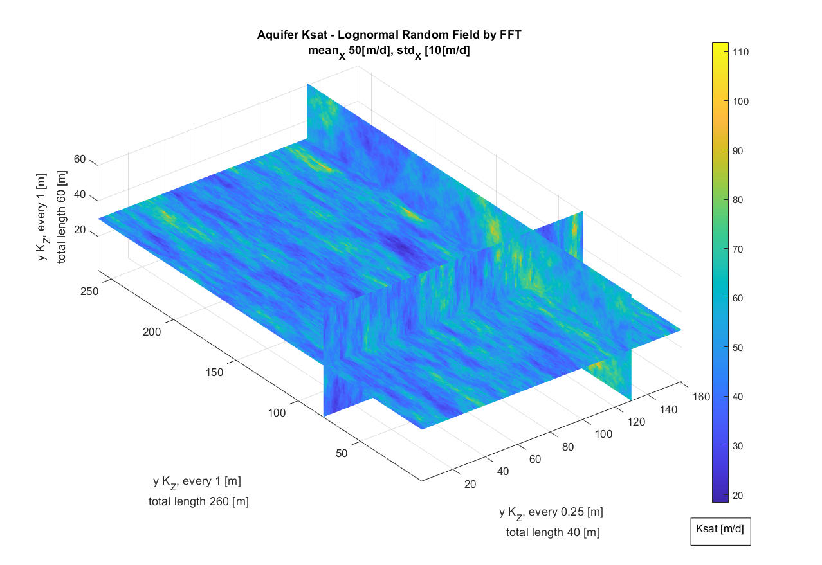

Figure – Example of a generated random field for the Wijk bij Duurstede aquifer. Point and spatial statistics gathered from field data, are used as input for the semi-variogram MATLAB code (Raas et al., 2018). The third dimension was idealized in view of COMSOL piping models operating in 3D but were never run due to lacking computational power.

The text data files, generated by the MATLAB code, are imported as a point cloud in COMSOL in function of spatial coordinates. The state variables are linearly interpolated inside the GRF coordinate boundaries, then mapped onto the FEM mesh, such that each node is attributed a unique hydraulic conductivity. The property is isotropic for each node, whereas the FEM resolution of Darcyan flow between adjacent elements will lead to preferential flow towards high Ksat nodes. This generates a layered anisotropic aquifer.

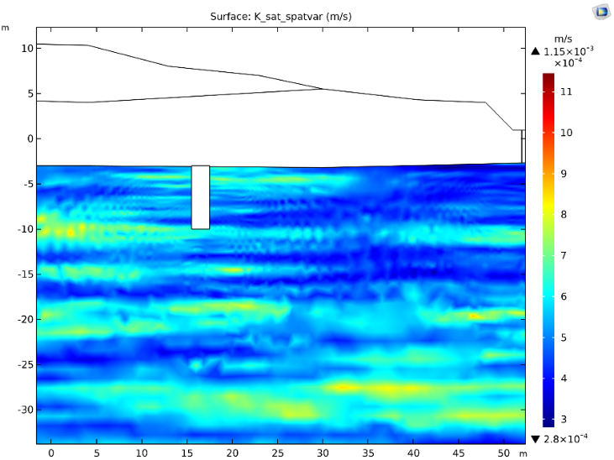

Figure - Anisotropic aquifer defined by the hydraulic conductivity variable K_(sand,GRF) as point-cloud import of the GRF(x,y,z). The spatial variability is defined by θv=1[m], θh=20[m], a lognormal distribution in point statistic with µ=50[m/d] and σ=10[m/d]

### SoSEAL Hydraulic Conductivity

The shear velocity of Al-OM flocs is linearly correlated to Darcy flow velocity (Tosco and Sethi, 2010). Due to the shear dependency of the SoSEAL technology, a linear reduction of the aquifer hydraulic conductivity is proposed to approximate the barrier’s permeability. Derived from the first pilot experiments, Zhou’s (2020) model was constructed using a maximal reduction factor of 50, while the minimum reduction remains unspecified. Nonetheless, Zhou (2020) quantified that the average reduction factor was 4 times the aquifer hydraulic conductivity.

Inspired by the latter, a linear reduction MATLAB code is proposed, which computes the barriers hydraulic conductivity (KSoSEAL) as a function of the aquifer flow (Ksat). The implemented average reduction factors are x5.8, x10.6, x25.9 (*see Figure 19*) as well as ~x51.8 (KSoSEAL,x25.9 divided by two).

Table - The hydraulic conductivity of the SoSEAL barrier is computed as a function of the background aquifer hydraulic conductivity. An average reduction is used to quantify the implemented “efficiency” of the barrier.

|  |  |  |  |
| --- | --- | --- | --- |
| **Average Reduction** | **Max(KSand,GRF)** Reduced by | **Min(KSand,GRF)**  Reduced by | **Method** |
| *5.8* | *40* | *1* | *Exponential* |
| *10.6* | *40* | *1* | *Linear* |
| *25.9* | *100* | *5* | *Linear* |
| *~51.8* | *200* | *10* | *Linear* |

To simplify the first design iterations, a simplified rectangular geometry is proposed in this model. Doing so allows sweeping of depth and width parameters for two barrier shapes (vertical and T barrier). The vertical barrier is the simplest implementation previously applied by push-injection of Al-OM flocs (Zhou, 2020), whereas the T shape is envisioned as providing additional seepage reduction at the cover-aquifer interface.

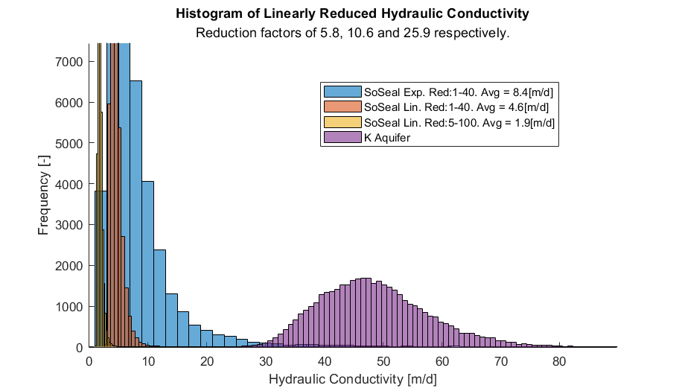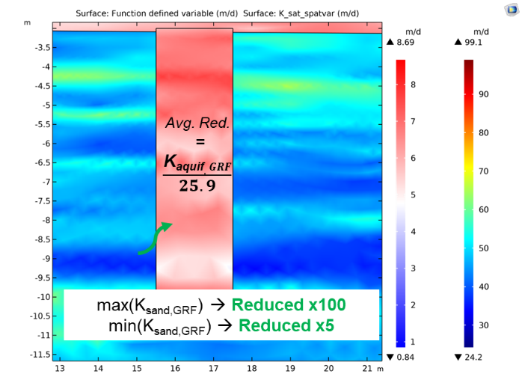

Figure – (Left) Anisotropic SoSEAL hydraulic conductivity K_(SoSEAL,GRF) computed as linear and exponential reductions of the aquifer’s hydraulic conductivity K_(sand,GRF) random field. (Right) The reduction favors preferential flow nodes, whereby the linear reduction reduces fastest flowing nodes by x100 and the slowest by x5, leading to an average reduction of x25.9. Note the spatial variability of the barrier.

# Results and Discussion

## Semi Permeable Barrier Principle

The SoSEAL barrier acts as a semi-permeable barrier. Partial horizontal flow still occurs in the Al-OM and soil matrix. This effect is combined with increased seepage length of flow forced below the barrier. A pipe modifies the flow field by acting as a drain, generating a steep hydraulic gradient at the pipe tip (*blue line,* *Figure 20*). In this research, the pipe tip progression is not modelled using iterative stepwise elements (*see 4.2.1 Current Practice*). Nonetheless, it can be seen how such a localized pressure gradient (hydraulic head dissipated over a length) is the motor for primary erosion to occur. Assuming non erodibility of the SoSEAL technology (to be verified in *SS1.4.*), implementing a semi-permeable barrier leads to three effects; Firstly, the pressure gradient in the pipe downstream is greatly reduced. Secondly, the hydraulic head dissipation occurs in the SoSEAL-soil matrix rather than at the pipe tip. Thirdly, the upstream flow is homogenized, undergoing predominantly linear hydraulic head dissipation until the SoSEAL barrier.

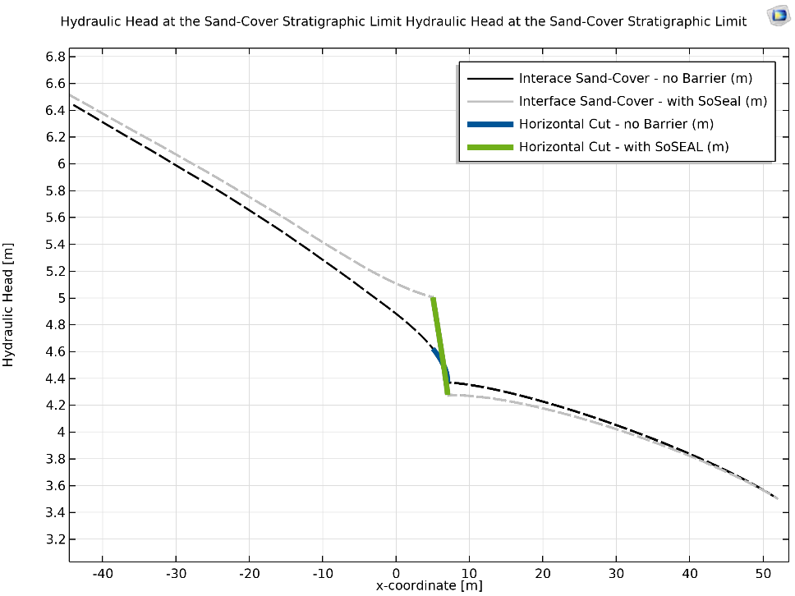

Figure - Hydraulic head distribution along the cover-sand layer interface, whereby the SoSEAL barrier (green) reduces the hydraulic head in the pipe domain downstream. The hydraulic diameter is 500um*8.2 and Darcyan flow is resolved using K*.

The semi-permeable SoSEAL barrier reduces the horizontal flow influx into the pipe from the tip. Such modifications to the seepage flow field reduce downstream pressure gradients in the pipe domain. To check the technology’s suitability, a range of sensitivity analyses are performed. These include the pipe domain (pipe progressions and hydraulic diameters) and barrier design (location, geometry and reduction efficiency).

## Piping Erosion - DP103

For piping erosion to occur, three failure criteria must be exceeded. As explained in the *Piping Theory 4.1*, an exit hole in the cover must be formed, the slurry in the crack must heave, after which piping erosion may occur. Most piping numerical models (Lachouette et al., 2008; Bersan et al., 2013; Aguilar-Lopez et al., 2016; Wewer et al., 2021; etc) and experiments (Van Beek et al., 2015; Pol et al., 2021; etc), focus exclusively on the channel erosion process, by assuming/fixing the failed two cover layer preconditions. Differently, this study is adapted to check all three piping criteria (*Figure 21*), while also focusing on erosion channel.

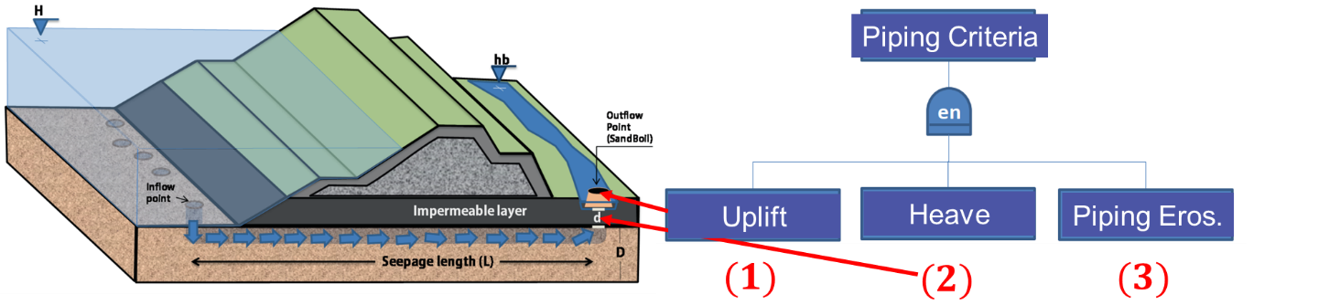

Figure - The piping failure mechanism can occur only when all three failure criteria (1-3) are exceeded. Dike illustration adapted from Aguilar-Lopez et al. (2018)

### **Uplift Check**

Cracking at the cover is expected to be most risky at the shallowest cover location; downstream of the levee lies a ~1.5m deep canal. The cover therefore reaches a minimum thickness of 3.65 [m]. Large structures safety assessments commonly implement limit state equilibrium equations (Bligh, 1910; Lane, 1935). To check whether failure could occur, the FEM gradient (*iFEM*) dissipated over this distance is compared to the cover’s minimum limit vertical gradient (*ic,h*) (Technical Committee of Flood Defenses, 1999). This is shown in *Figure 22*.

$$i_{FEM}=\frac{ϕ_{FEM} -h_{polder} }{d}=\frac{ϕ_{FEM} -3.5[m] }{3.65 [m]}$$

$$i_{c,h}=\frac{γ_{cover}^{'}}{γ_{w}}=\frac{8.0 to 6.5\frac{kN}{m^{3}}\left(1\right) }{10\frac{kN}{m^{3}}}=0.65 [-]$$

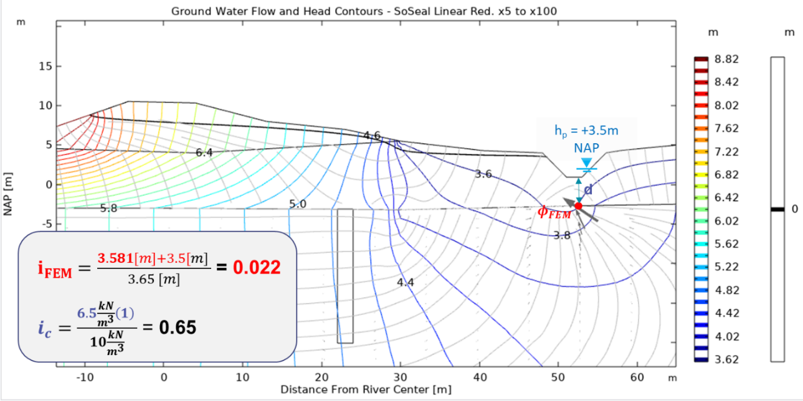

Figure - Seepage with the SoSEAL, prior to the exit hole formation. Unit weight γc2 = 16.5kPa (see 5.3). The streamlines in gray, the flow arrows indicate 2D flow tensor, the hydraulic head [m] in rainbow, the line of zero pressure head [m] in black.

The embedment depth of the SoSEAL is analyzed in the deep aquifer scenario overlain by the continuous cover (no exit hole). The depth of the barrier is varied from 10m to 28m, whereas the entire sandy aquifer extends over 34 meters. Additionally, the location of the 2m wide barrier is varied for three locations below the toe of the dyke. The uplift safety factor is defined as the cover resistance divided by the computed gradient at the base of the waterway (*Figure 23*):

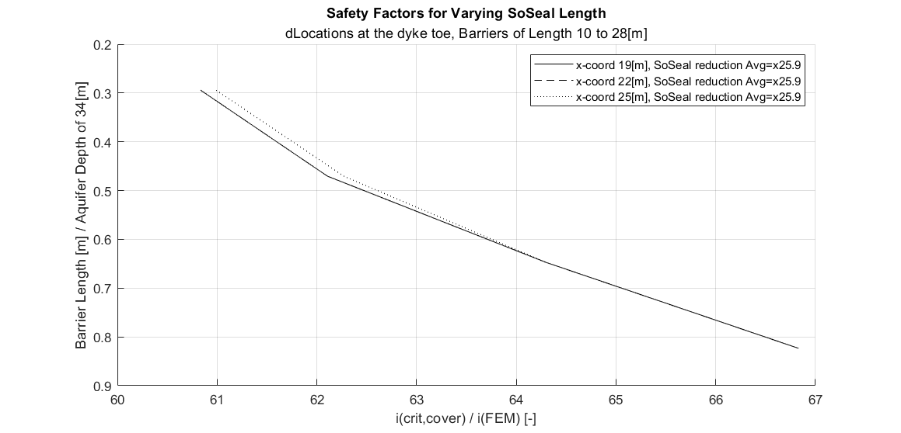

Figure - Resistance to cover uplift, defined by the unit weight dependent critical hydraulic gradient divided by the calculted FEM gradient. 𝑷_(𝒇𝒂𝒊𝒍,𝒖𝒑𝒍𝒊𝒇𝒕)=/=𝟏

Although not failing naturally, alternative exit holes could be formed in the cover layer. For example, anthropic agricultural installations could lead to local weakening of the layer. For this reason, the other piping criteria are computed in the sections which follow.

### **Heave Check**

Heave is assumed to be defined of the state of zero effective stress in the cover crack. This is achieved when the vertical flow is sufficient to exceed the weight of the soil matrix. Under sufficiently reduced effective stress, the fluidized material undergoes heave. Characterization of this phenomena remains poorly quantified. The Rijkswaterstaat (2017) attempt to utilize the unit weight of the cover material to defined the limit gradient.

$F_{H}=\frac{i_{c,h}}{i}=\frac{\frac{γ_{cover}^{'}}{γ_{w}}}{i}$ with $i_{c}=\frac{8.0-6.5\frac{kN}{m^{3}}\left(1\right) }{10\frac{kN}{m^{3}}}=0.8-0.65$

However, the void (model assumption) and slurry are not easily modelled. Furthermore, the model constrains a fixed geometry, whereas the whereas heave would be extremely sensitive to the defect’s shape and size. For these reasons, a simple indicator is calculated in *Figure 24* showing vertical gradients exceeding the limit gradient at the void-cover-aquifer interface. Assuming a circular crack of diameter 4cm (defined pessimistically following Pol et al.’s (2021) large scale piping erosion experiments) the local gradients easily exceed Terzaghi’s critical gradient.   
The aperture’s radius is an extremely sensitive input parameter, and although beyond the scope of this work, requires further research. Nonetheless, if the cover cracks by uplift, heave is always assumed as being possible. This node will therefore not be further studied and is assumed to be failing at all times.

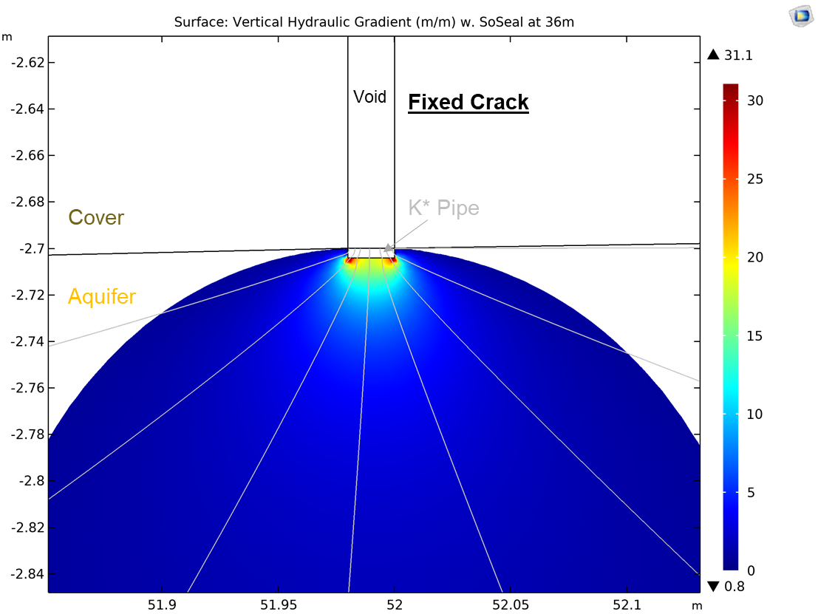

Figure - Pessimistic assumption: The local vertical gradient at the crack-aquifer interface easily exceeds Terzaghi’s critical gradient defined by self weight. It is therefore assumed that 𝑷_(fail,heave)=𝟏 at all times

### **Piping Erosion Check**

Assuming cracking of the cover layer *(7.2.1)* and heave in the cover (*7.2.2)*, the aquifer can depressurize at the sand boil location, leading to the onset of primary pipe erosion. As discussed in 4.2.2 Modelling Strategy, equilibrium back checking is performed on a predefined horizontal erosion channel. In short, the steady-state model predefines a horizontal erosion channel and back-checks its equilibrium state. The pressure gradients in the modelled pipe (*dh/dx,* also referred to as the load term (S) in the cubic law) are resolved in Darcyan flow according to the equivalent permeability (K*) of the pipe. Sellmeijer’s two force resistance term (R). Load and resistance terms are compared, dictating the limit grain equilibrium for a certain channel height of hydraulic diameter *a*. This is a function of the unitless channel height geometry factor *ng* and the 70th percentile grainsize *d70* (*a=ng*d70*)*.*

#### **Location**

For the deep aquifer archetype DP103, SoSEAL barrier location is optimized to reduce piping erosion susceptibility. Sweeping the X-coordinate is modelled for varying pipe extensions, whereby the channel start (pipe domain) is fixed at the crack and progression occurs upstream. The computed pressure gradients for a fixed channel height are shown in *Figure 25* - SoSEAL barrier location sweep, showing reduced pressure gradients for all pipe progression (%), the closer the barrier is to the cracked cover (crack at x-coordinate 52 [m]). At 100% progression the pipe domain extends until the SoSEAL, whereas for 50% progression it extends halfway between the crack and barrier.. For macro stability purposes, it must be noted that the toe of the dyke ends in the model at x-coordinates 20-25m. The sweep is run for a 100%, 50% and 25% progressed erosion channel.

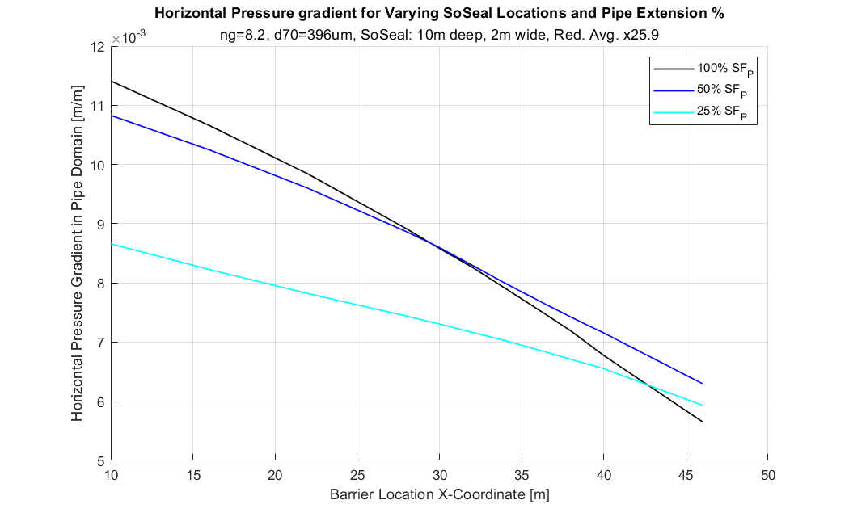

Figure - SoSEAL barrier location sweep, showing reduced pressure gradients for all pipe progression (%), the closer the barrier is to the cracked cover (crack at x-coordinate 52 [m]). At 100% progression the pipe domain extends until the SoSEAL, whereas for 50% progression it extends halfway between the crack and barrier.

Pressure gradients at distal SoSEAL locations are greater than if located close to the crack. For example, X-coordinates 10-20[m] model a 62% larger pressure gradient than x-coordinates 38-46[m]. Additionally, the steady state analysis shows larger pressure gradients in the pipe domain when extension is at 100%. This effect is reduced as the pipe length is reduced by constructing the barrier further downstream. For example, by increasing x-coordinate the pressure gradient dispersion between pipe progressions is reduced by an order of magnitude. At x-coordinate 10[m] yields a range of 2.8e-03[m/m], whereas the range at 46[m] is 6.4230e-04[m/m].

Location sweeping for a standard SoSEAL (x25.9 reduction, 10m deep, 2m wide) yields two results. Firsly, reducing the distance between the waterway and barrier reduces the pressure gradients for any pipe extension. The effect is most notable if the pipe has progresses and stopped in contact with the SoSEAL. This can be explained by the reduced drainage of the aquifer by shorter pipes, thus reducing the erosion potential. Secondly, the fully progressed pipe is most critical when considering the dyke toe location (necessary location to insure macro stability of the embedded structure). This result is not valid for short pipes (<20m, see *Figure 25*), since the area of reduced flow or ‘shadow-zone’, is sufficiently large with respect to the erodible length (crack-SoSEAL). Ergo, steady state solutions assuming full progression may be a pessimistic steady state scenario of the DP103 piping erosion.

To check whether a SoSEAL-cover layer gap is a critical node, a fixed channel geometry for a pessimistic SoSEAL barrier is modelled in tested. Interestingly, a 70[cm] disconnection leads to very small pressure (+5.5%) increase in the progressed pipe, probably due to the pre-existing horizontal seepage across the semi permeable barrier (*Figure 26*). The volume of water from the semi-permeable barrier should be similar orders of magnitude to that of a disconnected SoSEAL. Additionally, the relation to the two-force criteria of *Figure 26* for a fixed geometry (ng=8.2 and d70=500[µm]) is shown graphically in *Annex 10.1.8.*

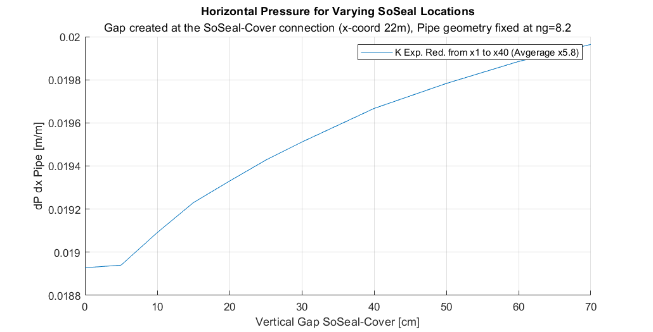

Figure - Pressure gradient increase in the pipe domain as the SoSEAL barrier is progressively disconnected from the cover layer. A pessimistic SoSEAL reduction is tested.

#### **Seepage Path**

Seepage paths in the aquifer’s subsurface are modelled and visualized by hydraulic head equipotential lines and flow velocity components. An evenly spaced, low resolution, mesh is chosen to visualize the flow tensors by local averaging. The model is run for 100% pipe progression and constant SoSEAL average reductions for two geometries (see *Figure 27*).

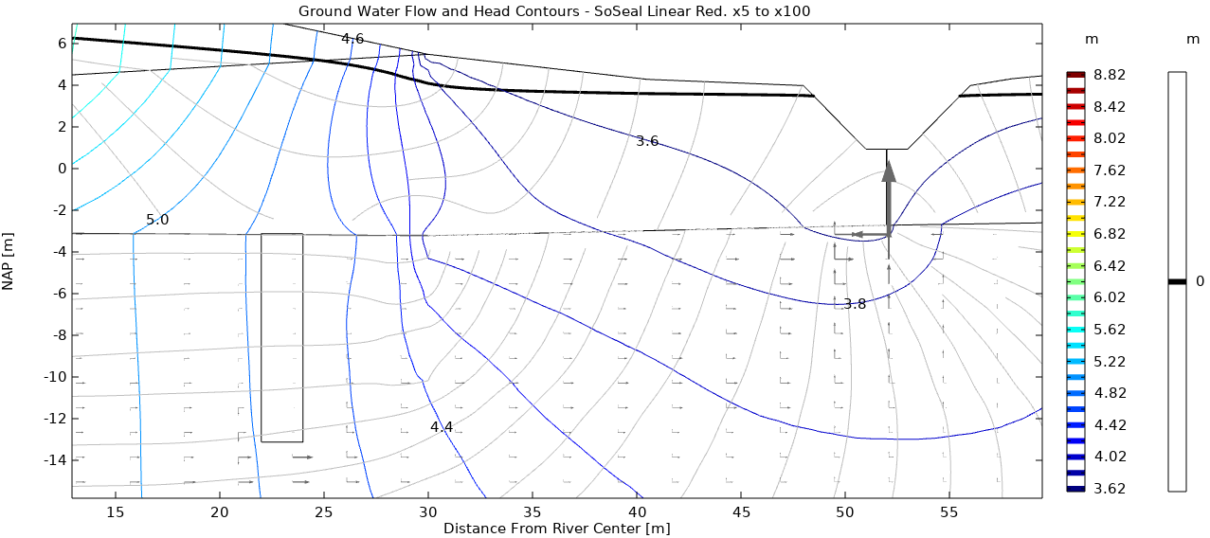

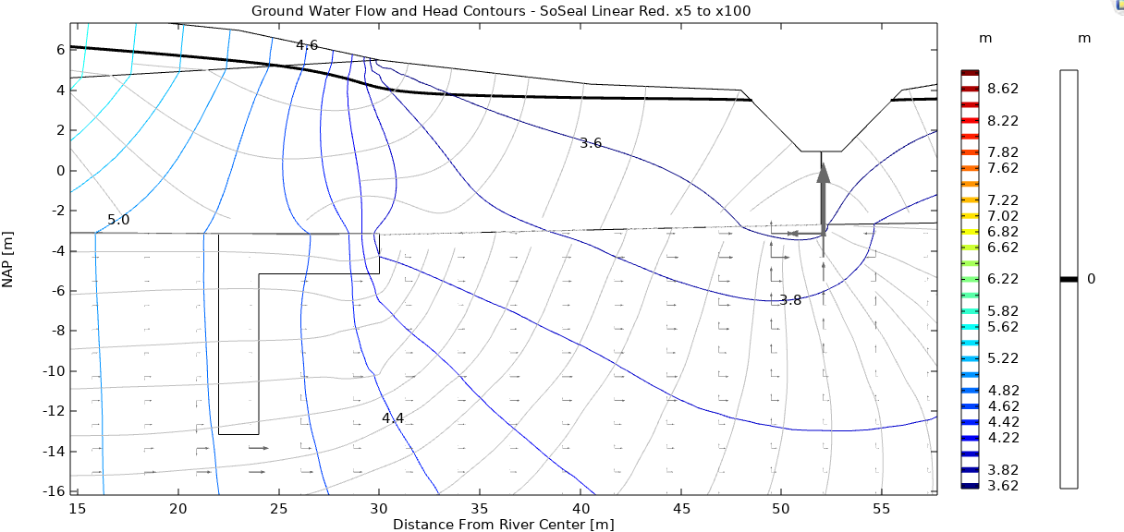

Figure - Hydraulic head distribution (rainbow), zero pressure head (black) and flow velocity components (arrows) for SoSEAL barriers (avg. reduction x25.9) located at the dike toe (x-coord. 22[m]). Both plots are taken for a channel of ng=4. Top: Vertical 10m deep, 2m wide barrier. Bottom: T-Shape 10m deep, 8m then 2m wide barrier.

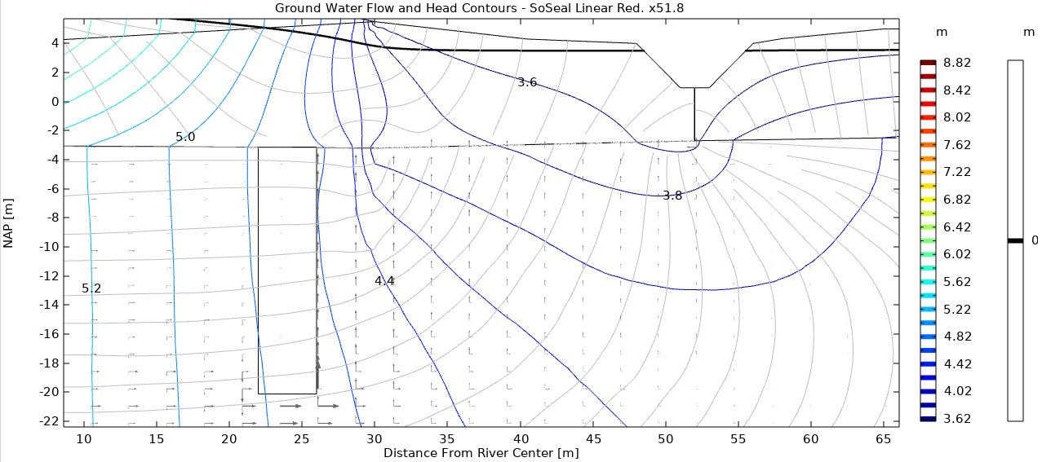

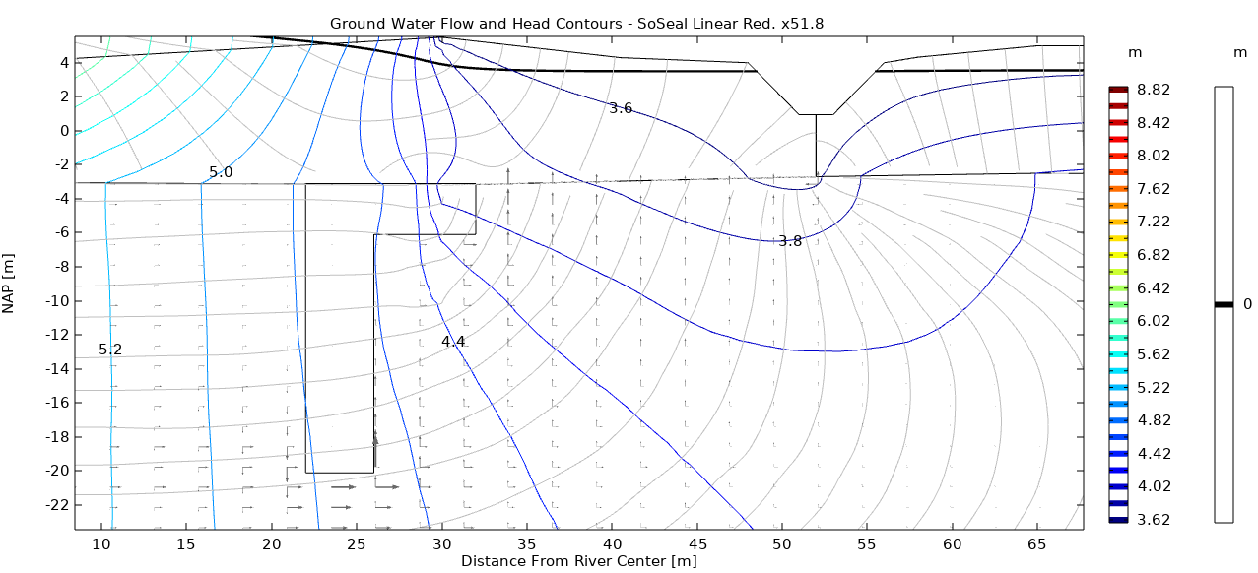

Figure - Hydraulic head distribution (rainbow), zero pressure head (black) and flow velocity components (arrows) for SoSEAL barriers (avg. reduction x51.8) located at the dike toe (x-coord. 22[m]). Both plots are taken for a channel of ng=4. Top: Vertical 17m deep, 4m wide barrier. Bottom: T-Shape 17m deep, 10m then 4m wide barrier.

The onset of piping erosion is modelled in steady state by a thin channel (*Figure 27 and Figure 28* with ng=4). Hydraulic head equipotential lines undulate in the decametric range, as a function of the spatially variable hydraulic conductivity. Topographical effects are prevalent around the aquifer-cover minima of -3.2 m NAP at x-coordinate 30[m]. This is the case for both a vertical and T-shaped barrier. Seepage directions are qualitatively displayed by flow velocity tensors. For 10[m] deep barriers, the vertical barrier is characterized by an extensive “shadow-zone” where flow is minimal. Differently, the T-shaped barrier introduces a vertical flow component at the downstream end of the barrier, flowing towards the pipe tip (Figure 27). Both models in *Figure 27* show the prevalence of horizontal seepage along the aquifer-pipe. Increasing the depth to 17[m] and average reduction of the barrier, favors vertical aquifer drainage towards the channel, with the discernible horizontal flow velocity occurring at >18[m NAP] for the vertical barrier (*Figure 28*). Differently, the T-shaped barrier introduces horizontal flow components downstream of the barrier, close to the pipe tip.

Decametric preferential flow occurs due to the layered system but remains a less sensitive parameter of the model. As seen by the striking similarity of hydraulic head equipotential lines for varying barrier geometries (*Figure 27*), the stratigraphic effects are notable in defining the aquifer’s hydraulic head distribution. Small undulations are visible in the hydraulic head distribution according to the layered SoSEAL regions with highest permeability. However, increasing the average SoSEAL permeability reduction factor forces a verticalization of seepage path significantly, but show similar hydraulic head distributions (*Figure 27* and *Figure 28*). Interestingly, for a small channel, the flow velocity tensors are strongly altered by the barrier depth. In 10[m] deep barriers flow vectors are preferentially horizontal in proximity of the pipe, whereas for 17[m] deep ones show primarily vertical components. The “shadow-zone” of reduced flow occurs in the 5-10[m] downstream of the SoSEAL and is most notable in the 10[m] vertical barrier (Figure 27 - Top). Convergence of flow at the pipe tip is noticeable in all T-shaped barriers (*Figure 27 – Bottom* and *Figure 28 - Bottom*). This process may increase water flux towards the pipe tip, which is undesirable in the mitigation of piping erosion.

#### **Parametric Study**

The pipe is created and enlarged by increasing the unitless channel height geometry factor ng (*ng=a/d70, with a the hydraulic diameter*). Sweeping for it allows the d70 to be a fixed model parameter, automatically calculating variables and geometries which are a function of the hydraulic diameter (*a*). The pressure gradients in the modelled pipe (*dh/dx*) are compared to Sellmeijer’s sand grain equilibrium criteria (red line). To guarantee piping prevention all lines must be situated below the Sellmeijer line.   
Aguilar-Lopez et al. (2016) argue the circular and square cross sections are most critical in triggering sand particle rolling, due to the reduced cross-sectional area. For this reason, the circular geometrical cross section factor is fixed at βfi = 64.0 (Bersan et al., 2013 in 10.1.5). Most piping literature have found large scale experiments to fail with ng 10 to 30. Similarly, Pol et al. (2021) found that pipe depth varies 2 −20 times d50, and the pipe width is 20 −100 times d50. The ng­ parameter is sweeped in the large scale model, checking the equilibrium condition for all channel heights (ng=1-30). If the loads exceed the resisting forces for any value of ng, the domain is deemed highly susceptible to piping.

To predict the effect of SoSEAL on piping risk at the Wijk bij Duurstede dike toe (x-coordinate 22m), various scenarios are modeled. Firstly, the impact of vertical SoSEAL barriers and increasing average reduction are shown in *Figure 29*. Secondly, the model computes the effect of both vertical and T-shaped barriers in *Figure 30*. The same tests are run for an intermediate sand layer scenario, which are included in *Figure 40* (*8.1.11 Annex K)*. Their aim is to quantify SoSEAL’s effect as an anti-piping measure by reducing the channel pressure gradients.

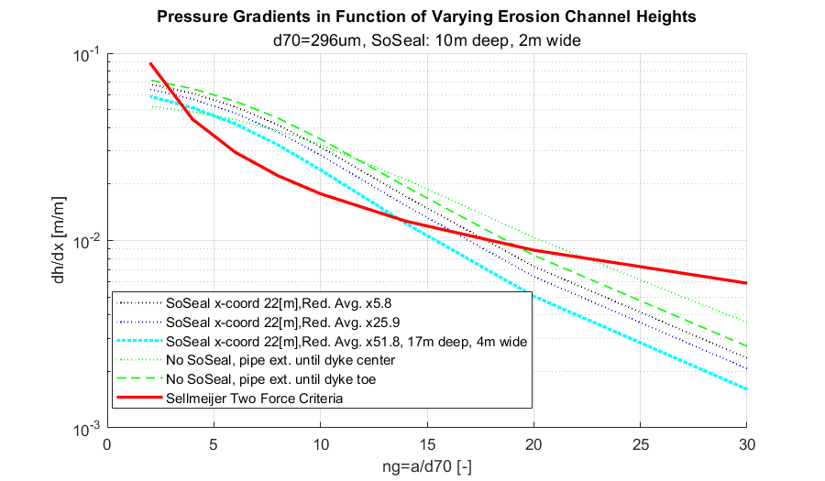

Figure - Channel height geometry factor (ng=a/d70, with a the hydraulic diameter) parametric sweep for the dyke toe location at DP103 (x-coordinate 22[m]). The SoSEAL is a vertical 10[m] deep, 2[m] wide barrier. Sellmeijer’s criteria is calculated for a horizontal channel. Progressive widening of the pipe shows loss of equilibrium at a threshold hydraulic diameter a = 2.9-3.8 * d70. Equilibrium is only reestablished at a= 13.9-24.0 * d70.

Sellmeijer’s two force resistance criteria (R) is exceeded by the load term (S) in the pipe domain for all vertical barriers tested in the deep aquifer. Compared to the scenario without the SoSEAL, the threshold hydraulic diameter after which piping erosion may occur increases by embedding barriers with average reduction factors of x5.8, x25.9 and x51.8 (*Figure 29*). In fact, the threshold increases by +6.6% (ngthresh=3.11), +14.2% (ngthresh=3.33) and +24.7% (ngthresh=3.63) respectively. Pipe stability under secondary erosion is re-achieved when the load term is reduced below the resistance criteria. Barriers with increasing average reduction factors stabilize sooner, such that equilibrium hydraulic diameters are reduced by -5.8% (ngequil=18.4), -12.4% (ngequil=17.1) and -29.5% (ngequil=13.8) in comparison to the model without barrier.

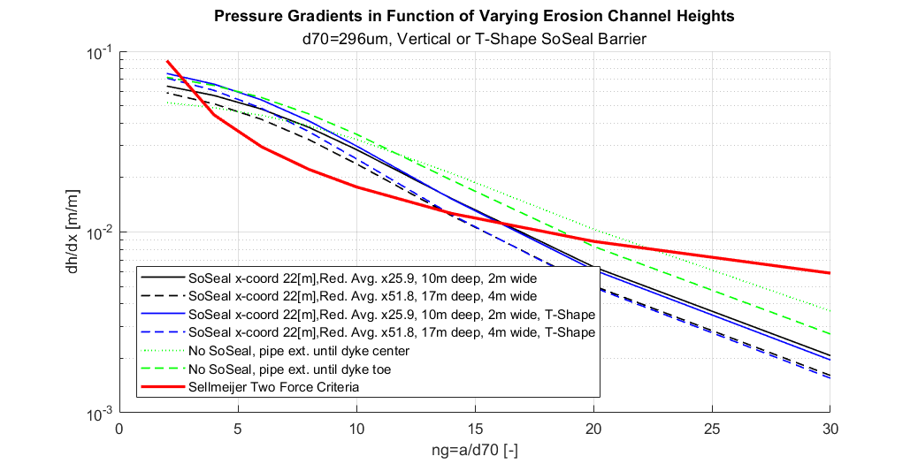

Figure - Channel height geometry factor (ng=a/d70, with a the hydraulic diameter) parametric sweep for the dyke toe location at DP103 (x-coordinate 22[m]). The SoSEAL modelled by a vertical and T-shaped barrier. Sellmeijer’s criteria is calculated for a horizontal channel. Progressive widening of the pipe shows loss of equilibrium at a threshold hydraulic diameter a = 2.8-3.8 * d70. Equilibrium is only reestablished at a= 13.8-24.0 * d70.

Similarly, the equilibrium criteria is exceeded in the deep aquifer model for the T-shaped barrier (*Figure 30).* A shallow 10[m] T-shaped barrier reduces the threshold hydraulic diameter by -4.8% (ngthresh=2.77), while reducing the equilibrium channel height by -13.4% (ngequil=16.9). A 17[m] deep one increases the threshold hydraulic diameter by +4.4% (ngthresh=2.77), while reducing the equilibrium channel height by -28.9% (ngequil=13.9). Upsloping erosion channel models of DP103 increase the resistance (R) during primary erosion, lowering the threshold equilibrium ng value by +2.3% to +6.5% (*see Annex 10.1.10)*.

Interestingly, if the DP103 archetype is modified to include an intermediate low permeability layer, the results differ significantly (See *Annex 10.1.11*). Threshold instability without the SoSEAL is reached at ng=8, whereas with any embedded SoSEAL the pipe domain is stable for all ng values. At the mentioned channel height, average reduction factors x5.8, x25.9 and x51.8 reduce the pipe domain pressure gradients by -9.7%, -14.4% and -16.0% in comparison to the model without barrier.

The vertical barrier is most efficient in reducing the piping potential, as seen by always increasing the lower threshold ng value (*Figure 29*). This is critical in minimizing the onset of primary erosion. Differently, the T-shaped barrier can have negative effect in pipe development, whereby one model iteration even lowers the threshold ng value with respect to no SoSEAL (*Figure 30*). This shape consistently leads to larger pressure gradients in the pipe domain at low hydraulic diameters. Such phenomenon could be explained in the deep aquifer scenario, whereby the same volume of water is drained at a concentrated pipe tip location (intrinsic to the design of the T shape). The re-equilibration channel height is not sensitive to barrier type (vertical or T-shaped), but rather by the SoSEAL average reduction and depth. Over construction in the deep aquifer model is not sufficient to guarantee stabilization of the piping erosion criteria. In fact, even a 17[m] deep SoSEAL with x51.8 average reduction isn’t sufficient in the deep aquifer DP103 archetype. However, if a silt layer is modelled, an average SoSEAL reduction of x25.9 SoSEAL for sufficient resistance against piping.

## Design Verification

A design verification model is run for the most promising SoSEAL barrier: a 10[m] deep, 2[m] wide barrier with an average reduction factor of x25.9. At the dyke toe location (x-coordinate 22[m]). The model sweeps both varying channel progressions and channel heights. *Figure 31* and *Figure 32* show the results for the DP103 specific deep aquifer and intermediate layer model respectively.

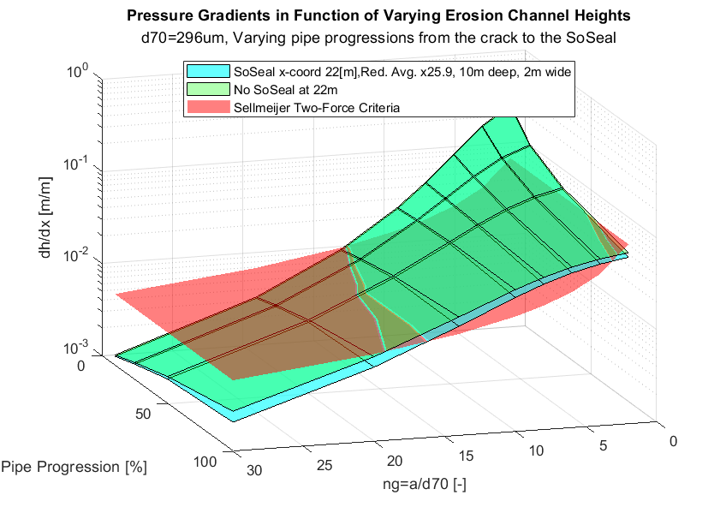

Figure - Location specific model quantifying the DP103 design of a SoSEAL barrier (x25.9 as per Zhou (2020)) located below the toe of the dyke (x-coordinate 22[m]). Varying pipe progressions and channel height geometry factor (ng=a/d70, with a the hydraulic diameter) are swept. Sellmeijer's two force criteria is exceeded.

Both the barrier free and SoSEAL model show exceedance of Sellmeijer’s criteria in the pipe domain at 10%, 25% and 50% progression for any channel height (*Figure 31*). Meanwhile, at 100% progression the channel erodibility without barrier occurs at ngthresh=2.91, whereas with the SoSEAL in place it augments to ngthresh=3.33 (+14.2%). Additionally, re-equilibration during secondary erosion is achieved earlier with SoSEAL in place, especially for channel progressions >50%.

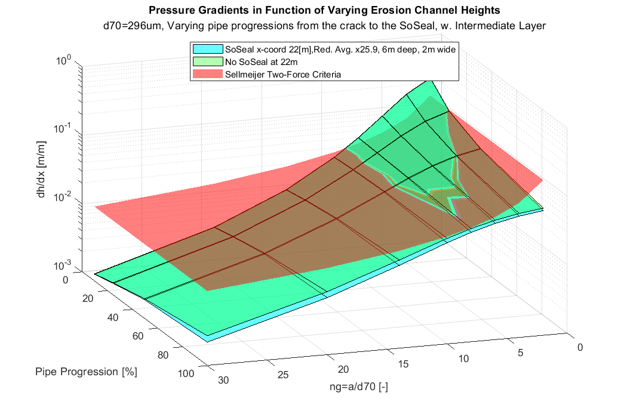

Figure - Location specific model quantifying the DP103 + intermediate layer (6m confined aquifer by 5m silt, K=0.05[m/d]) design of a SoSEAL barrier (x25.9 as per Zhou (2020)) located below the toe of the dyke (x-coordinate 22[m]). Varying pipe progressions and channel height geometry factor (ng=a/d70, with a the hydraulic diameter) are swept. Sellmeijer's two force criteria is not exceeded if pipe progression is 100% until the SoSEAL.

When an intermediate layer is introduced in the model, both the barrier free and SoSEAL results do not fail with 100% pipe progression (*Figure 32*). Meanwhile, under 50% progression the channel erodibility without barrier commences at ngthresh=3.98, whereas with the SoSEAL in place it augments to ngthresh=4.29 (+8.03%). Additionally, the barriers role is negligible during pipe initiation (≤10%).

For both an unconfined and confined aquifer scenario, the SoSEAL barrier has a most notable effect at large channel progressions (>50% of the DP103 location specific seepage path). Furthermore, for both models the barriers’ role is negligible in reducing initial erodibility (<10% progression). This can be explained by the long seepage path (30m) where the downstream “shadow zone” (5-10m) effects progressed channels to a greater extent.   
Including an intermediate layer, shows the models’ sensitivity to the aquifer’s volume, rather than barrier efficiency and channel progression. The unconfined scenarios always exceed equilibrium (*Figure 31*). In other words, the location specific critical head is exceeded (H1000yr>Hc) and piping is assumed to occur and be progression dominated. Large scale experiments at the Delta Flume and IJkdijk have shown such progressive scenarios to monotonic erode a channel in time (Pol et al., 2021). Alternatively, the confined aquifer scenario (*Figure 32*) shows a stabilizing pipe at ~70% channel progression. Ergo, the reduced drained flux only leads to regressive piping scenarios, whereby given a constant head boundary (such as the H1000yr at Wijk bij Duurstede) equilibrium would be reached after initiation (Van Beek et al., 2015).

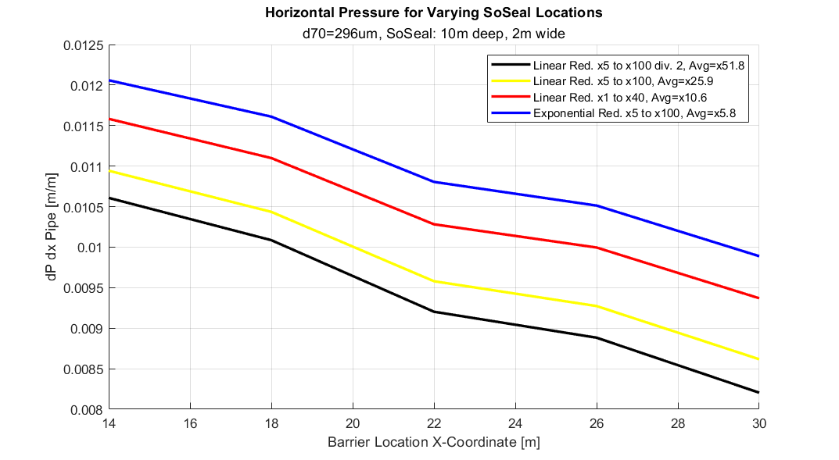

Figure - Barrier efficiency increases by augmenting the average reduction. The location sweep shows constant efficiency improvements for any location. The most pessimistic SoSEAL is shown in blue, whereas the overdesigned SoSEAL is shown in black.

To quantify the relative effect of increased Al-OM efficiency in reducing the background permeability, a location sweep is performed for a specific barrier geometry. *Figure 33* shows a constant improvement for any location when the average reduction factor increases from the pessimistic x5.8 to x10.6, x25.9 and x51.8. The DP103 location specific design (x-coordinate 22[m]) reduces horizontal pressures in the pipe, by -4.8%, -11.3% and -14.8% in comparison to the most pessimistic barrier tested. Therefore to conclude, when doubling SoSEAL’s average reduction factors, the largest relative increase in efficiency is achieved by a factor of x25.9 (*Figure 33*).

# Conclusion

## Modelling Approach

The parametrization of the pipe was done by implementing cubic law formulations of the permeability in elongated pipes (Bersan et al., 2013; Aguilar-Lopez et al., 2016). Such approach allows precise and efficient resolution of the high aspect ratio Wijk bij Duurstede FEM. Dykes with cohesive cover layers are generally progression dominated, and an equilibrium is often achieved given a constant head (Van Beek et al., 2005). Since the study location is defined by a similar lithology, the steady state equilibrium is checked for varying channel sizes. If Sellmeijer’s criteria is exceeded for any hydraulic diameter greater than zero (ng>0), piping erosion is assumed to occur. The steady state cubic law model is extremely sensitive to the grainsize selected, whereby a pessimistic parameter selection of 396µm may induce overdesign. Such model is extremely pessimistic, as it foregoes the concept of channel progression. The pipe is modelled according to a predefined channel of constant height, which is not representative of real pipe progression in an anisotropic aquifer (Van Beek et al., 2015). Additionally, various simplifying assumptions reduced the resistance term (*R*) significantly. Sediment transport equations are not considered in this single-phase flow model. For example, the slurry resistance through the exit hole isn’t modelled, channel wall roughness isn’t considered, channel tortuosity elongation of rolling path is not considered, turbulence is not modelled, vertical migration of the pipe and more. The model may therefore induce great overdesign, by underrepresenting the resistance terms. Nonetheless, the upsloping channel (α=+1.32°) provides additional resistance against piping, requiring smaller cross sections to before destabilizing grains. In fact, the pipes limit equilibrium hydraulic diameter is reduced by X% with respect to a Sellmeijer’s horizontal criteria. Therefore, when taking account for the upsloping pipe in Wijk bij Duurstede the resistance to piping increases. The absence of time dependence and progression render the model pessimistic, in that it assumes a fixed geometry and checks whether the pressure gradient in the pipe exceeds Sellmeijer’s criteria. A failing domain for a given geometry does not provide any information on the erosion phase, and thus always assumes progressive erosion to occur. Ergo, equilibrium can only be back-checked in the steady state.

To conclude, the piping erosion model and equilibrum calcilations are very pessimistic. **Scope 4** is met but in a sub optimal manner. The COMSOL model quiantifies the pressure gradients in the pipe using a cubic law, but yields sub-optimal results due to it’s very pessimistic governing assumptions. If used exclusively to quantify piping erosion, it may induce overdesign of the SoSEAL.   
Additionally, a very sensitive parameter is the aquifer thickness. **Scope 2** is met, as both the thick and intermediate sand layer scenarios are modeled in the internship report. According to this modelling approach, the internediate sand layer scenario is almost not prone to piping erosion, for which implementing the SoSEAL barrier effectively prevents the risk entirely.

## SoSEAL Design

Location   
 The location sweep of DP103 shows that reducing the distance between the waterway and the SoSEAL reduces the piping erosion potential. The optimal location must remain below the dyke toe for macro stability purposes and is fixed at x-coordinate 22[m] in the model. Additionally, in this location, the fully progressed pipe is most critical (largest horizontal pressure gradients). Poor SoSEAL-cover connection led to minimal increased risk of piping erosion.

Seepage Path  
The SoSEAL’s spatially variable hydraulic conductivity mimics background anisotropy, resulting in decametric preferential flow paths. A vertical barrier reduces flow significantly in the “shadow-zone”, which ranges ~0.5-1times the barrier depth. Horizontal flow components and a large “shadow-zone” are most notable when the SoSEAL average reduction is x25.9 times Kaquifer (10[m] deep). Meanwhile, an overdesigned barrier (eg. x51.8 average reduction, 17[m] deep) leads to flow verticalization, which may lead to heave risk and vertical channel progression if a pipe where to develop until the SoSEAL (100% progression).

Parametric Study  
The vertical barrier geometry is the most efficient geometry in reducing the onset of piping erosion potential, as shown by increasing ngthresh values. The T-shaped barrier may even increase piping erosion susceptibility. Deep aquifer models of DP103 do not result in preventing piping for any modelled average reductions, depth, and width, even if the embedded structure is highly overdesigned. Nonetheless, the channel height range for which Sellmeijer’s criteria is exceeded is reduced by larger and more impermeable barriers.

Design Verification  
The proposed modelling approach yields failing equilibrium criteria for the simulated SoSEAL vertical barrier design (10[m] deep, 2[m] wide). Total aquifer discharge towards a pipe is extremely sensitive in the model, as shown by the deep aquifer results of DP103. In fact, Pol et al. (2021) expect that a larger aquifer and deeper aquifer, with a higher discharge, leads to increased pipe dimensions. Ergo, even the overdesigned barrier at 100% progression (17[m] deep, 4[m] wide in *Figure 29*) is not expected to equilibrate before stopping at the barrier. For this reason, the erodibility of the SoSEAL technology remains a critical knowledge gap in stopping progressive piping erosion. If an intermediate layer is added, the model reaches channel equilibrium (for progressions <100%).   
Design verification results show maximal efficiency when the SoSEAL Al-OM flocs reduce the aquifer’s hydraulic conductivity by an average reduction factor of x25.9. To achieve such a barrier in a spatially variable domain, the aquifers hydraulic conductivity must be reduced by x100 times in fast flowing stratigraphy, while slow flowing areas must be reduced by at least x5 times. Implementation of such a barrier was shown to be successful in large scale pilot projects utilizing the SoSEAL technology (Zhou, 2020).

In summary, the research proposes a design in function of the calculations performed in the SoSEAL barrier piping erosion FEM for DP103 (see *Table 5*). The model represents very well the location specific subsurface data by random aquifer anisotropy, responding optimally to **Scope 1**. Additionally, a tool is developed which allows efficient and polyvalent SoSEAL modelling of barrier anisotropy as a function of the aquifer hydraulic conductivity, which also responds optimally to **Scope 3**. Lastly, the location specific design such as location, geometry and reduction factors are also tested thoroughly in the model, responding optimally to **Scope 5**.

Table - Project-specific design guidelines of an optimized SoSEAL barrier design at the WAM Wijk bij Duurstede – Amerongen tract (DP103). The location, geometry and average reduction factors are specified

|  |  |
| --- | --- |
| **Proposed Design** | |
| *Barrier Shape* | Vertical (by push-injection method) |
| *Location x-coordinate [m]* | 22 (dyke toe) |
| *Depth [m]* | 10 |
| *Width [m]* | 2 |
| *Average Reduction Factor [-]* | x25.9 |
| *Minimum and Maximum Reduction [-]* | x5 and x100 |

## Evaluation of Interhnship Scope and Research Targets

The scope of the internship was proposing an initial numerical study for steps SS1.2. and SS4. The implementation considered and built upon the outcomes of the failure path analysis SS1.1. The internship deliverable consisted in developing a replicable tool which calculates the SoSEAL effect on piping erosion for project-specific normative situations (archetypes). A piping finite element model (FEM) was implemented in COMSOL. Semi-variograms in MATLAB were used to generate a spatially variable domain for the aquifer and barrier. Lastly, the SoSEAL design was tested. More specifically the deliverable is assessed with respect to the targets set in *1.4 Scope and Research Targets*.

Table - Final evaluation on internship scope and research targets, aimed at answering SS1.2. and SS4. with as an initial numerical approach.

|  |  |  |
| --- | --- | --- |
| **Scope** | **Target** | **Evaluation** |
| *1* | *Characterize and model DP103 ~ subsurface data. Include spatial variability.* | **Optimal** |
| *2* | *Model the thick aquifer (primary focus) and the intermediate layer scenario* | **Okay** |
| *3* | *Develop a tool suitable for designing the SoSEAL* | **Optimal** |
| *4* | *Analyze the anti-piping model and SoSEAL effect* | **Sub-optimal** |
| *5* | *Optimized the barrier design for DP103 (Location, geometry and average reduction factors)* | **Optimal** |

## Future Recommendations

The same model could implement a simple fully impermeable barrier for comparison to the semi-permeable one used currently. This would serve an interesting comparison to verify the degree of pessimism of the piping erosion model, as well as the sensitivity to aquifer depth. An extremely long barrier is expected to drastically reduce the risk of piping.   
To respond to the sub-optimal anti-piping model (too pessimistic), the results presented in this research should be simulated in the D-Geo flow, as per current practice. Nonetheless, the program lacks the design tools for embedded infrastructure, let alone a semi-permeable anisotropic barriers. The feasibility of reproducing SoSEAL in D-Geo flow should be analyzed alongside Deltares specialist.

Additionally, direct use of the proposed COMSOL FEM could take advantage of the spatially variable layered aquifer, the SoSEAL injection could also be modelled prior to checking the piping criteria. This could be used to provide location specific injection parameters. Zhou (2020) implemented a reactive transport model which coupled Darcyan flow and solute transport in COMSOL, to simulate the distribution of Al-OM precipitates. For a fixed injection location below the toe of the dyke (in the model referred to as x-coordinate 22[m]), the SoSEAL injection would distribute in function of the soil layering.   
Lastly, stochastic simulations of the model could be implemented with sufficient processing power and scripting. Firstly, the following process must be fully automatized: generate a random field for grainsizes or hydraulic conductivity (Ras et al., 2019), read the output text file in COMSOL as a point cloud, attribute the aquifer and corresponding SoSEAL material property (*κsat, κSoSEAL*), run the pipe channel height sweep (*ng*), compute and export the pipe pressure gradients. Secondly, a stochastic simulation could run the fully automatized process N-times. This would be beneficial in analyzing the role of spatial variability and preventing over-design of the SoSEAL by implementing a probabilistic approach.

In the future, complex numerical models may address all issues simultaneously. For example, current academic state of the art works towards multi-phase flow modelling, time dependency, meandering and 3D pipe progression according to a generated random field of particles. Implementation of such methods in commercial software is far from being realized but may be studied alongside the SoSEAL (and other semi permeable barriers) in future research. The investment may be cost saving however, as “…a 3D configuration was found to result in significantly lower critical gradients than those predicted by an accepted calculation model calibrated on the basis of 2D experiments.” (Van Beek et al., 2015).

# Appendix

## Additional Specifications

### Annex A

See the full pumping report and HPT data in the “Field Characterization – DP103, Pumping Report” pdf.

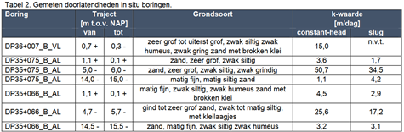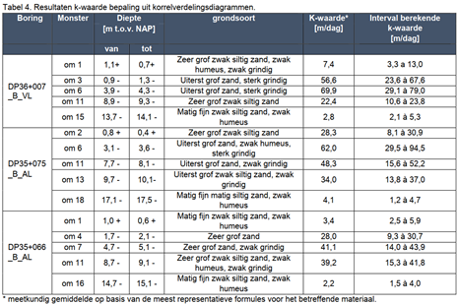

### Annex B

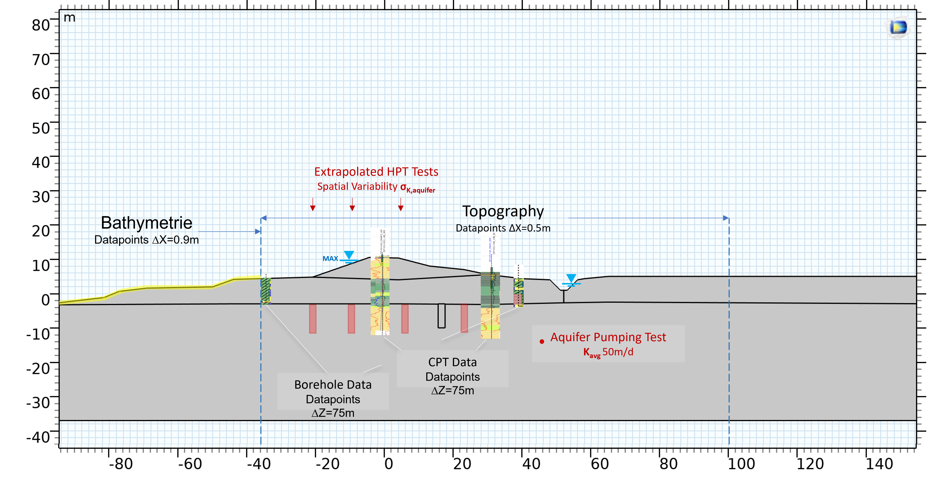

### Annex C

| **Name** | **Expression** | **Value** | **Description** |
| --- | --- | --- | --- |
| *K_dyke* | 0.05[m/d] | 5.787E−7 m/s |  |
| *K_sand* | 50 [m/d] | 5.787E−4 m/s |  |
| *K_cover* | 0.01[m/d] | 1.1574E−7 m/s |  |
| *K_SoSEAL* | 1[m/d] | 1.1574E−5 m/s |  |
| *Hw* | 8.82 [m] | 8.82 m | Water level |
| *Hs* | 5 [m] | 5 m | Avg Soil Level |
| *H_inland* | 3.5 [m] | 3.5 m | Hydro Head Inland behind dyke |
| *rho_soil* | 2000[kg/m^3] | 2000 kg/m³ | Soil density |
| *rho_wat* | 1000[kg/m^3] | 1000 kg/m³ | Water density |
| *phi_sat* | 30[deg] | 0.5236 rad | Friction angle for saturated soil |
| *phi_un* | 20[deg] | 0.34907 rad | Friction angle for unsaturated soil |
| *rho_sand* | 1900[kg/m^3] | 1900 kg/m³ | Sand density |
| *nu_dyke* | 0.4 | 0.4 | Poisson's ratio Dyke |
| *nu_soil* | 0.4 | 0.4 | Poisson's ratio Soil |
| *nu_sand* | 0.45 | 0.45 | Poisson's Ratio Sand |
| *nu_SoSEAL* | 0.45 | 0.45 | Poisson's ratio SoSEAL |
| *E_soil* | 100[MPa] | 1E8 Pa | Young's modulus Soil |
| *c* | 25[kPa] | 25000 Pa | Cohesion |
| *FOS* | 1 | 1 | Factor of Safety |
| *E_sand* | 100[MPa] | 1E8 Pa | Young's Modulus Sand |
| *epsi_dyke* | 0.25[1] | 0.25 | Porosity Soil |
| *epsi_sand* | 0.4[1] | 0.4 | Porosity Sand |
| *epsi_soil* | 0.3[1] | 0.3 | Porosity Soil |
| *epsi_SoSEAL* | 0.25[1] | 0.25 | Porosity Soil |
| *D* | 10[m] | 10 m | SoSEAL Barrier Height |
| *W* | 2[m] | 2 m | SoSEAL Barrier Width |
| *L1* | 22 [m] | 22 m | SoSEAL Barrier X-Position (topleft corner) |
| *ng* | 8.2 [1] | 8.2 | erosion height channel factor |
| *D70* | 2.96*10^ - 4[m] | 2.96E−4 m | D70 sand aquifer |
| *a* | ng*D70 | 0.0024272 m | Pipe height |
| *Whites* | 0.25 [1] | 0.25 | Whites constant, rolling resistance grains term |
| *Dhid* | a | 0.0024272 m | Hydraulic diameter (square/circular pipe) |
| *beta_fi* | 64.00 | 64 | Cross section shape factor (circle = more critical) |
| *theta_res* | 37 [deg] | 0.64577 rad | Sand grain rolling resistance angle |
| *eta_w* | 1.306*10^(-6) [m^2/s] | 1.306E−6 m²/s | kinematic visco water 10C |
| *kappa_fict* | 2*(Dhid^2)/beta_fi | 1.841E−7 m² | pipe fictitious permeability equivalent |
| *K_fict* | kappa_fict* (9.81 [m/s^2]/eta_w) | 1.3829 m/s | pipe fictitious hydro cond equivalent |
| *L* | L1 + W | 24 m | pipe end |
| *dp_dx_crit* | (pi/3)*((rho_sand - rho_wat)/(rho_wat))*D70*Whites*tan(theta_res)/a [m/m] | 0.021653 | Van Esch 2013 critical horiz gradient pipe |
| *alpha* | atan((P_SC_3y - P_SC_2y)/(P_SC_3x - P_SC_2x)) | 0.022744 rad | Pipe inclination for Sellm. 2006 |
| *dp_dx_critSell* | (pi/3)*((rho_sand - rho_wat)/(rho_wat))*D70*Whites*sin(theta_res + alpha)/(cos(theta_res)*a) [m/m] | 0.022301 | Sellmeijer 2006 critical horiz gradient pipe |
| *P_SC_1x* | 0 [m] | 0 m |  |
| *P_SC_1y* | -3[m] | −3 m |  |
| *P_SC_2x* | 30[m] | 30 m |  |
| *P_SC_2y* | -3.2 [m] | −3.2 m |  |
| *P_SC_3x* | 51.98 [m] | 51.98 m |  |
| *P_SC_3y* | -2.7 [m] | −2.7 m |  |
| *R2* | 0.02 [m] | 0.02 m | Diameter Pipe |
| *gamma_s* | 19[kN/m^3] | 19000 N/m³ |  |
| *gamma_w* | 10[kN/m^3] | 10000 N/m³ |  |

### Annex D

% =====================================================================

% GRFS: Gaussian Random Field Simulator - Exponential covariance

%

% Copyright (C) 2019 Ludovic Raess, Dmitriy Kolyukhin and Alexander Minakov.

%

% Modified by Rocco Wennubst Pedrini, TU Delft 2022

% =====================================================================

%% SoSEAL SLD Domain - GRF for Spatially Var Ksat in a Layered Aquifer

clear; clc; fclose('all');

reset(RandStream.getGlobalStream);

% aquifer

mu_X = 50; % [m/d] mean hydraulic conductivity

sigma_X = 10; % [m/d] 95% confidence (std) from max pumping of 70m/d

mu_lognorm = log( mu_X^2 / (sqrt (mu_X^2 + sigma_X^2)) ); % lognormal mean

sigma_lognorm = sqrt( log(1 + (sigma_X^2 /mu_X^2 ))); % lognormal std

% physics

Lx = 260; % domain size in x

Ly = 40; % domain size in y

Lz = 1; % *3rdD in SoSEAL Model z=1 nx=1* domain size in z

sf = 1; % standard deviation Gauss distr

If = [20.0, 1, 20.0]; % correlation lengths in [x,y,z]

% numerics

Nh = 5000; % inner parameter, number of harmonics

nx = 261; % numerical grid resolution in x

ny = 161; % numerical grid resolution in y

nz = 1; % *3rdD in SoSEAL Model* numerical grid resolution in z

dx = Lx/nx; % numerical grid step size in x

dy = Ly/ny; % numerical grid step size in y

dz = Lz/nz; % numerical grid step size in z

% preprocessing

C = sf/sqrt(Nh);

Yf = zeros(nx,ny,nz);

tmp = zeros(nx,ny,nz);

% action

tic % timer

for ih = 1:Nh

fi = 2.0*pi*rand;

% Gaussian spectrum

flag = true;

while flag

k = tan(pi*0.5*rand);

d = (k*k)/(1.0+(k*k));

if rand<d

flag = false;

end

end

theta = acos(1-2*rand);

V1 = k*sin(fi)*sin(theta)/If(1);

V2 = k*cos(fi)*sin(theta)/If(2);

V3 = k*cos(theta)/If(3);

a = randn;

b = randn;

for iz=1:nz

for iy=1:ny

for ix=1:nx

tmp(ix,iy,iz) = dx*(ix-0.5)*V1 + dy*(iy-0.5)*V2 + dz*(iz-0.5)*V3;

end

end

end

Yf = Yf + a*sin(tmp) + b*cos(tmp);

end

Yf = C*Yf;

**% GRF to Lognormal RF of Ksat_Sand**

Yf_Ksat = exp(mu_lognorm + sigma_lognorm.*Yf);

K_avg = mean(reshape(Yf_Ksat.',1,[]));

%--------------------------------------------------------------

**% Ksat_Sand to SoSEAL (homogeneous, linear and expontential)**

SoSEAL_reduction_max = 100; %hydro cond reduction factor

SoSEAL_reduction_min = 15;

Yf_KSoSEAL_homog = Yf_Ksat/SoSEAL_reduction_max;

X_01 = ( Yf_Ksat(:,:,1)-min(min(Yf_Ksat(:,:,1))) )/( max(max(Yf_Ksat(:,:,1)))-min(min(Yf_Ksat(:,:,1))) ) ;

Linear_reduction = (Yf_Ksat(:,:,1)-min(min(Yf_Ksat(:,:,1))) ).*((SoSEAL_reduction_max-SoSEAL_reduction_min)./( max(max(Yf_Ksat(:,:,1)))-min(min(Yf_Ksat(:,:,1))) ) ) ;

Yf_KSoSEAL_linear = Yf_Ksat ./ Linear_reduction;

Exp_reduction = (exp(6*(X_01)) ./ max(exp(6*(X_01))) ) * SoSEAL_reduction_max;

Yf_KSoSEAL_exp = Yf_Ksat(:,:,1) ./ Exp_reduction;

SoSEAL_reduction_max2 = 40; %hydro cond reduction factor

SoSEAL_reduction_min2 = 1;

Yf_KSoSEAL_homog2 = Yf_Ksat/SoSEAL_reduction_max2;

X_01_2 = ( Yf_Ksat(:,:,1)-min(min(Yf_Ksat(:,:,1))) )/( max(max(Yf_Ksat(:,:,1)))-min(min(Yf_Ksat(:,:,1))) ) ;

Linear_reduction = (Yf_Ksat(:,:,1)-min(min(Yf_Ksat(:,:,1))) ).*((SoSEAL_reduction_max2-SoSEAL_reduction_min2)./( max(max(Yf_Ksat(:,:,1)))-min(min(Yf_Ksat(:,:,1))) ) ) ;

Yf_KSoSEAL_linear2 = Yf_Ksat ./ Linear_reduction;

Exp_reduction = (exp(6*(X_01_2)) ./ max(exp(6*(X_01_2))) ) * SoSEAL_reduction_max2;

Yf_KSoSEAL_exp2 = Yf_Ksat(:,:,1) ./ Exp_reduction;

% Inf corrections

Yf_KSoSEAL_linear(isinf(Yf_KSoSEAL_linear)) = prctile(reshape(Yf_KSoSEAL_linear.',1,[]), 97.5);

Yf_KSoSEAL_linear2(isinf(Yf_KSoSEAL_linear2)) = prctile(reshape(Yf_KSoSEAL_linear2.',1,[]), 97.5);

Yf_KSoSEAL_exp(isinf(Yf_KSoSEAL_exp)) = prctile(reshape(Yf_KSoSEAL_exp.',1,[]), 97.5);

Yf_KSoSEAL_exp2(isinf(Yf_KSoSEAL_exp2)) = prctile(reshape(Yf_KSoSEAL_exp2.',1,[]), 97.5);

lin_avg = mean(reshape(Yf_KSoSEAL_linear.',1,[])); lin_avg2 = mean(reshape(Yf_KSoSEAL_linear2.',1,[]));

exp_avg = mean(reshape(Yf_KSoSEAL_exp.',1,[])); exp_avg2 = mean(reshape(Yf_KSoSEAL_exp2.',1,[]));

%-----------------------------------------------------------------------

toc

%coord vectors

X = [-100:(Lx/(nx-1)):Lx-100]; Y = [-Ly:(Ly/(ny-1)):0]; Z = [0:(Lz/(nz-1)):Lz];

**%output text file - SoSEAL mod**

fileID1 = fopen('Gaussian2D_output_SoSEAL_red5_100.txt','w');

for i = 1:nx

for j = 1:ny

fprintf(fileID1,'%f %f %f %f %f\n',X(i),Y(j),Yf_KSoSEAL_homog(i,j,1),Yf_KSoSEAL_linear(i,j,1),Yf_KSoSEAL_exp(i,j,1)');

end

end

fclose(fileID1);

### Annex E

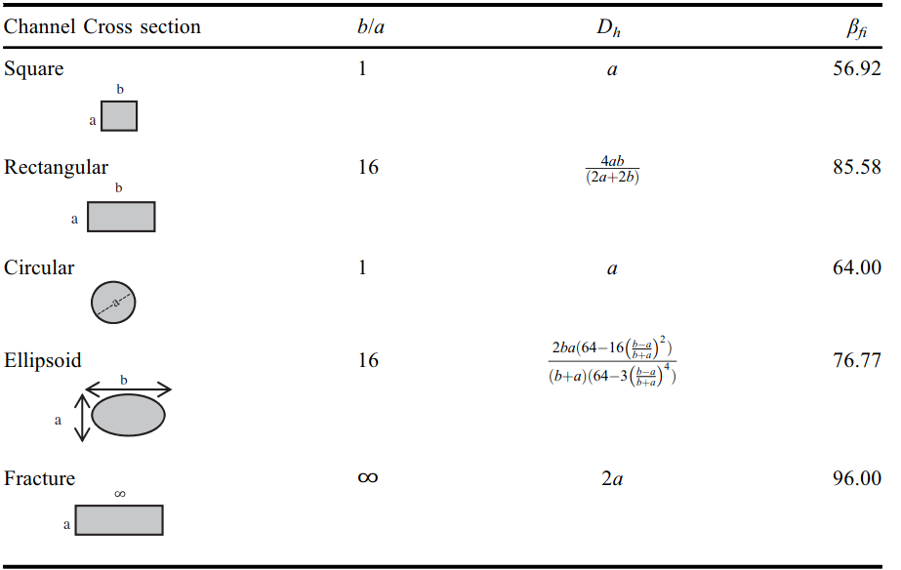

Figure - Cross section geometrical factors used in the cubic law (Bersan et al., 2013; Muzychka and Yovanovich, 2009).

### Annex F

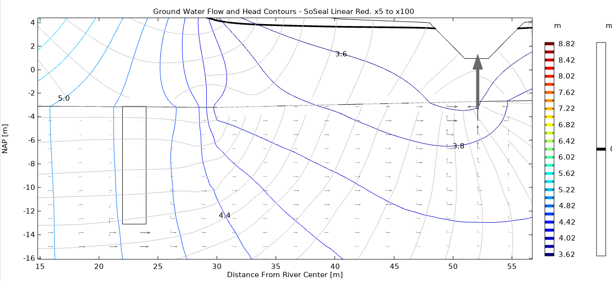

Figure - Uplift check model results, displaying vertical and horizontal seepage velocity vectors. Note the forced horizontal flow below the barrier (red. avg. = x25.9), shielded downstream region, and congregated flow in the waterway.

### Annex G

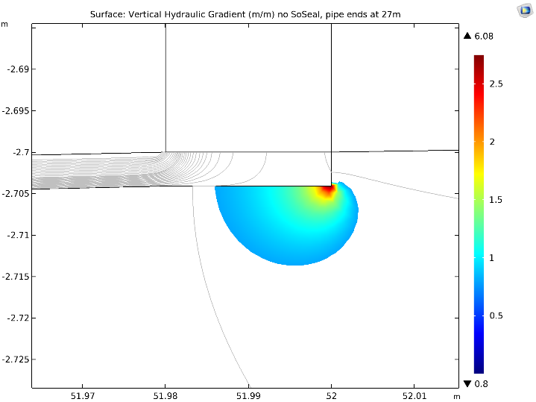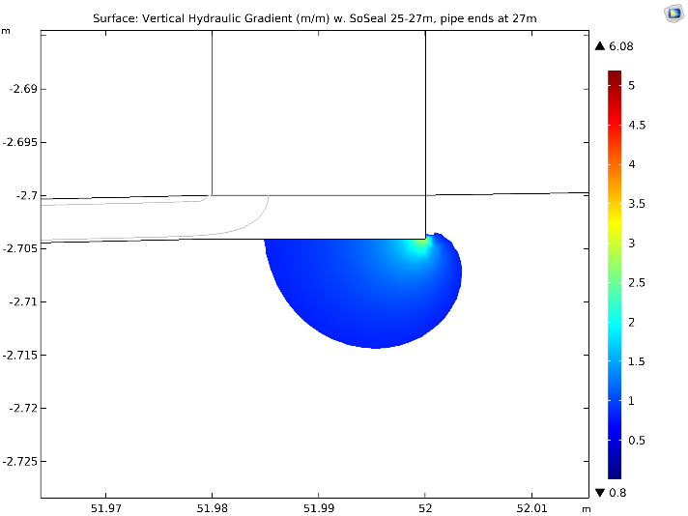

Figure - Heave check at the aquifer-pipe with the cracked cover interface, both times with a pipe developped until x-coord 27[m]. In color any gradient exceeding the sand self weight. Left: No SoSEAL. Right: With SoSEAL between 25-27[m].

### Chart, table Description automatically generatedAnnex H

Figure - Disconnected SoSEAL simulation, displaying the pressure gradients in the pipe (green), which increase for increasing disconnection with the cover layer. The two force equilibria are shown (red) for a fixed channel geometry of ng=8.2 and d70 of 500um.

### Annex I





Figure - - Hydraulic head distribution (rainbow), zero pressure head (black) and flow velocity components (arrows) for overdesigned SoSEAL barriers (avg. reduction x51.8) located at the dike toe (x-coord. 22[m]). Top: Vertical 17m deep, 4m wide barrier. Bottom: T-Shape 17m deep, 10m then 4m wide.

### Annex J

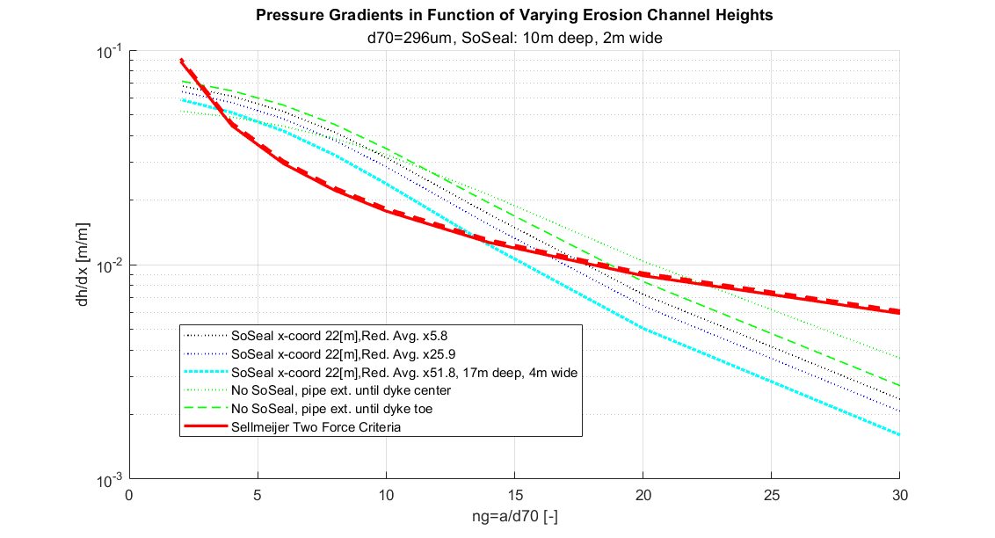

Figure - Comparison of increased resistance from an upsloping erosion channel (+1.32deg in DP103). The limit equilibrium increases from 3.33 d70 to 3.42 d70, ergo a 2.8% increase.

### Annex K

An intermediate layer is modelled by confining 6m of the aquifer summit with a 5m silt layer with Kintermed=cover = 0.05[m/d]. The SoSEAL begins at the cover-aquifer interface and terminates at the aquifer-intermediate layer interface.

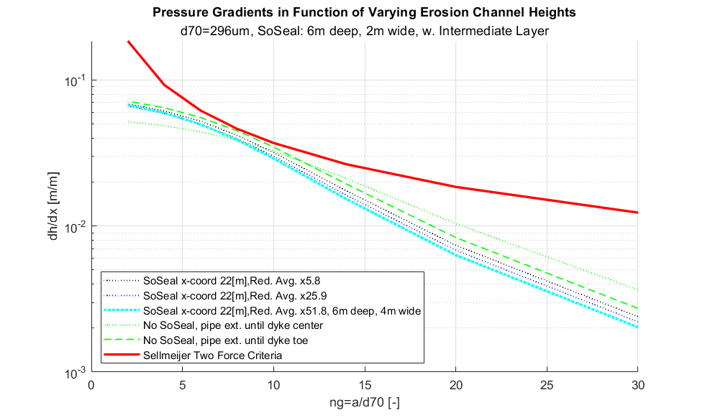

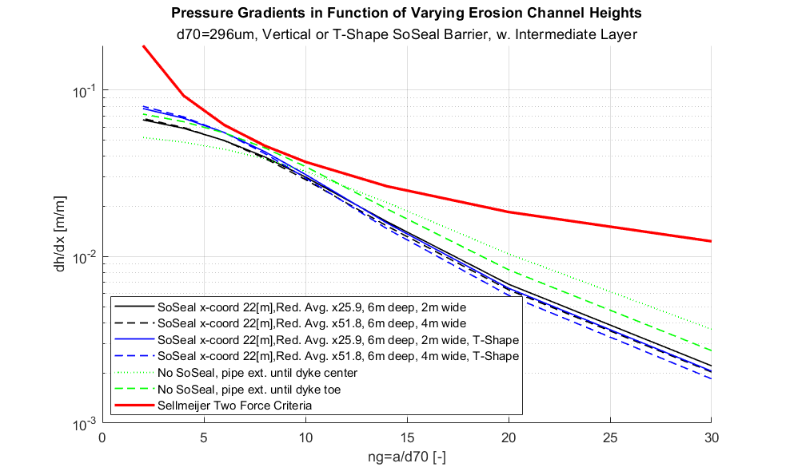

Figure - Channel height parametric sweep for the dyke toe location at DP103 (x-coordinate 22[m]). The SoSEAL is a vertical (top) or T-shaped barrier (bottom). Sellmeijer’s criteria is calculated for a horizontal channel. No SoSEAL calculates threshold instability at ~8*d70, whereas vertical barriers render the domain stable for all ng values.

### Annex L

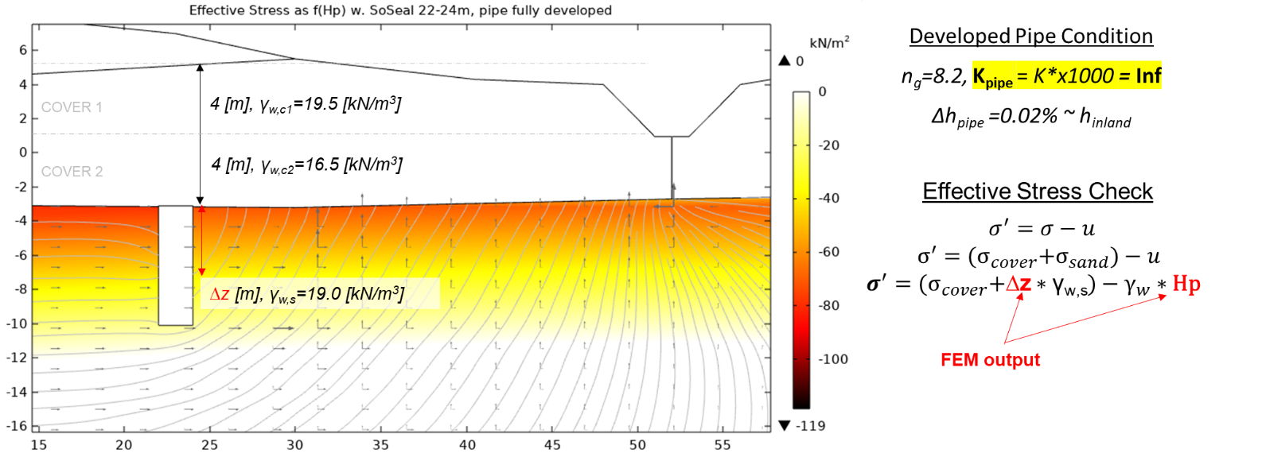

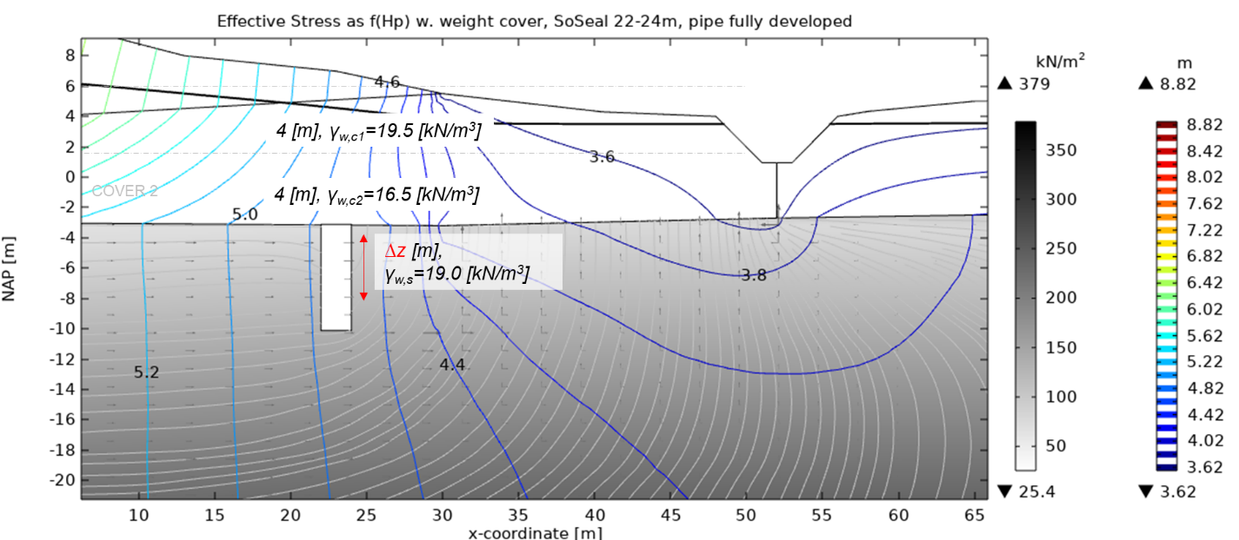

Figure - Heave check at the base of the fully developed pipe. (Top) No cover weight, assumed void leading to negative effective stress. (Bottom) Full cover 4m+4m overburden in the effective stress calculation.

## **Linear Approximation**

The FEM model’s resolution of the Darcy’s linear law, results in nonlinear pressure distribution in the pipe. This is intrinsic to the finite element model resolution of the governing equation. However, the cubic law method is derived from a Navier-Stoke laminar flow resolution of incompressible media. This assumes nonturbulence and zero pipe surface roughness. Ergo, the flow velocity should be equivalent to a linear pressure gradient.

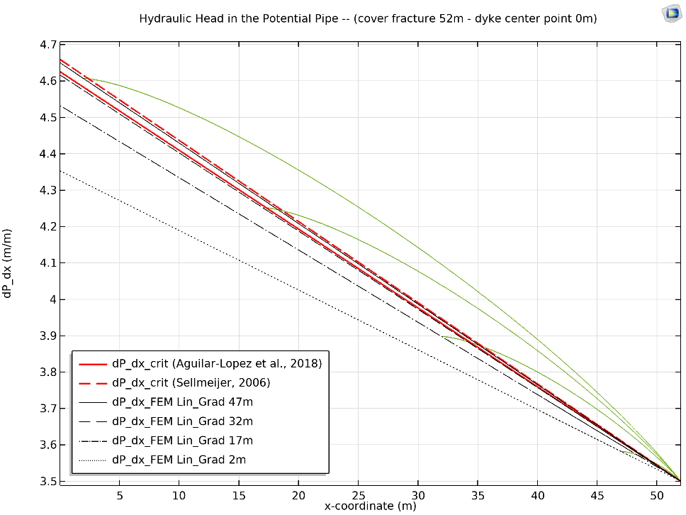

Figure - Modelled dissipation in the DP103 cover-aquifer erosion channel, without SoSEAL. Four different pipe lengths are modelled for ng­=8.2. Their progression ranges from the crack location at x-coordinate 52[m], progressing upstream until the center-point of the dyke at x-coordinate 0[m] (green curves). Note the nonlinear head dissipation, versus the linear approximations (black lines). The limit equilibrium criteria for a horizontal and sloped channel +1.32deg are solved for ng=8.2 (red lines).

To match this, the ${\frac{∂P}{∂x}}_{FEM}$ is linearly approximated by integrating over the pipe domain (see red line, *Figure 42*). The domain integral is additionally verified by a linear operator calculating the average tangent of the hydraulic head at the pipe centerline (a/2). This verification consistently calculates consistently lower values by <0.1%.

The domain integral is computed as:

$${\frac{∂P}{∂x}}_{FEM}= \int{ \frac{\frac{dH}{dx}*(x>x_{tip})}{x*(x>x_{tip})}dx}$$

This gradient must be less than the resistance terms (R), after which the flows momentum is sufficient to induce grain rolling and commence backward erosion.

## Laminar Flow

Pipe flow equations for closed-conduit or parallel plat approximations are derived from Hagen-Poiseuille, which assumes laminar and incompressible flow. This is deemed valid in fine to medium sands (Robbins and Van Beek, 2017).   
To verify the validity of the Navier-Stoke laminar flow approximation by the fictive permeability method, the Reynolds number is computed over the seepage domain. Under fully developed Laminar flow in a circular pipe requires *Re* < 2300. The expected flow in a sandy sublayer is of laminar nature (Sellmeijer, 2006).

$$Re= \frac{ρ*u{*D}_{pipe}}{μ}=\frac{u*a}{ν}$$

*u [m/s] Horizontal flow velocity  
a [m] Pipe hydraulic diameter  
ν [m2/s] Kinematic viscosity at 10°C*

|  |  |
| --- | --- |
| Pipe Length (no SoSEAL) | Reynolds Number |
| 24 [m] | **2105.4** |
| 34 [m] | **1974.5** |
| 44 [m] | **1768.3** |

Nonetheless, the role of wall turbulence and turbulent flow remains poorly understood (Pol et al., 2021).

## **Empirical Piping Criteria**

The resistance to erosion is dependent to the qualities of the sand layer adjacent to the aquitard, and the seepage path a pipe may take. The exit point is fixed by stratigraphy, and the model assumes a fixed existing crack location in the waterway downstream. Ergo, the piping and heave criteria assuming a fractured cover must be checked. Simple empirical formulations assume sub-horizontal aquifer-cover interfaces, rendering the DP103 location suitable for a first order approximation ($\frac{dy}{dx}=\frac{+0.5m}{22m}=1.32°$). Nonetheless, the slight inclination upwards towards the fictive fracture location in the waterway, is unfavorable for facilitating water flow. Ergo, the empirical calculations must be scrutinized.

### Foreland Damping

A thin foreland has a reducing effect on piping, where the theoretical entry point of water seeping from the riverbed occurs as function of the distribution range of the cover layer (λ1). The equivalent length of the foreland is therefore expressed by Zwanenburg (2011). The geometrical parameters are derived from the archetype DP103 model. Nonetheless, the actual foreland extend is extremely uncertain, and simplified to a horizontal layer of equal thickness (d1), which is not representative of the project specific lithologies.

*K1 [m/s] Cover hydr. conductivity  
K2 [m/s] Sand hydr. conductivity $L_{v}$ 
 [m] Foreland length  
D [m] Aquifer Depth  
d1 [m]Average Foreland thickness $λ_{1}$ 
 [m] Distribution range*

|  |  |  |  |  |  |  |
| --- | --- | --- | --- | --- | --- | --- |
|  | **K1** [m/d] | **K2**[m/d] | **Lv** [m] | **D** [m] | **d1** [m] | **L’v** [m] |
| *Pessimistic* | 0.1 | 50.0 | 40 | 30 | 2 | **39.30** |

Increasing the seepage length under a constant sand layer height allows for a greater critical head to be supported by the levee. The horizontal seepage length L is therefore defined as the pathway:

$$L=L{}_{dyke}+L_{v}^{'}=51 \left[m\right]+39.93 \left[m\right] \\ L=90.30 [m]$$

### Sellmeijer 1989 and 2011

Backward erosion empirical fitting of stationary Navier-Stoke and Darcy-Brinkman flow calculations allow the integration of soil property parameter values. Fine tuning of the Sellmeijer criterion provides an easy handling, and fast approach to initially characterize the risk of piping erosion.   
According to Sellmeijer et al. (2011) and calculation of the scale and geometrical shape factor are controlled by seepage length. The FEM COMSOL model geometry and boundaries are read via a LiveLink matlab code to evaluate the critical head Hc.

|  |  |
| --- | --- |
| Sellmeijer et al. (2011) | Sellmeijer et al. (1989) |
| $$\frac{∆Hc}{L}=F_{R}F_{S}F_{G}$$ $$F_{G}=0.91{\left(\frac{D}{L}\right)}^{\frac{0.28}{{\left(\frac{D}{L}\right)}^{2.8}-1}+0.04} F_{S}=\frac{d_{70}}{\sqrt[3]{κL}} F_{R}=η\frac{γ_{p}^{'}}{γ_{w}}tan⁡(θ)$$ | $$∆Hc=α*c*\frac{γ_{p}^{'}}{γ_{w}}\tan\left(θ\right)*\left(0.68-0.10\ln\left(c\right)\right)*L$$ $$α={\left(\frac{D}{L}\right)}^{\frac{0.28}{{\left(\frac{D}{L}\right)}^{2.8}-1}} c=η\frac{d_{70}}{\sqrt[3]{κL}} κ=\frac{ν}{g}K$$ |

*∆Hc [m] Critical Head  
L [m] Horizontal seepage length  
D [m] Aquifer Depth  
η [-] Whites constant  
d70 [m] Sand grain diameter  
κ [m2] Intrinsic permeability  
γ’p [kg/m3] Unit weight of sand  
γw [kg/m3] Unit weight of water  
θ [°] Sand rolling resistance angle  
ν [m2/s] Kinematic viscosity at 10°C  
K [m/s] Aquifer hydr. conductivity*

|  |  |  |  |  |
| --- | --- | --- | --- | --- |
|  | ***DP103*** | ***Source*** | | ***Explanation*** |
| *Height of Sand* ***D*** *[m]* | *30* | *(Bersan, CRUX)* | | *Confined aquifer depth* |
| *Seepage length* ***L*** *[m]* | *90.30* | *(see Foreland Damping)* | | *Horizontal seepage length* |
| *Whites Constant* ***η*** *[-]* | *0.25* | *(Aguilar-Lopez et al., 2016)* | | *Uptake of shear stress of a single particle in a bed* |
| *Effective Unit Weight* ***γ’p****[kg/m3]* | *1900* | *(Bersan, CRUX)* | |  |
| *Rolling Resistance of Sand* ***θ*** | *37°* | *(Sellmeijer et al., 2011)* | | *Maximal sand rollover resistance angle* |
| ***d70*** *[m]* | *296e-6* | *(see Grainsizes)* | | *Minimum grainsize at DP102+070 BUT* |
| ***d50*** *[m]* | *242e-6* | *(see Grainsizes)* | | *Minimum grainsize at DP102+070 BUT* |
| *Hydraulic Conductivity* ***K*** | *50* | *(see Aquifer Hydraulic Conductivity)* | | *Must be the 95% confidence value* |
|  | | | | |
| **Assumed Seepage Length** | ***Ldyke*** | | ***L*** | |
| ***∆Hc*** *[m] Sellmeijer 2011* | ***3.70*** | | ***5.39*** | |
| ***∆Hc*** *[m] Sellmeijer 1989* | ***3.30*** | | ***6.29*** | |

In the presence of abundant laboratory testing, refined critical head approximations include parameters accounting for particle and soil specific relative density, uniformity, and angularity by Sellmeijer et al. (2012).

### Lane and Bligh

Lane and Bligh’s rules are utilized as common practice in Bijlage III (Ministerie van Infrastructuur en Milieu, 2017) for first order quantification of the critical head, providing an additional check prior to the FEM. Additionally, Lane is the unique criteria which includes the vertical contribution to increased resistance underneath an impermeable barrier below a dyke.

|  |  |  |  |  |
| --- | --- | --- | --- | --- |
| Lane 1910 (Rijkwaterstaat 1999) | | Bligh 1935 (Rijkwaterstaat 1999) | | |
| $$∆Hc=\frac{{\frac{1}{3}L}_{h}+L_{v}}{C_{w,creep}}$$ | | $$∆Hc=\frac{L}{C_{creep}}$$ | | |
| **NEN 5104** | $$C_{w,creep}$$ | **NEN 5104** | |  |
| ***D50*** *150-210 [µm]* | *7* | ***D50*** *105-150 [µm]* | | *18* |
| ***D50*** *210-300 [µm]* | *6* | ***D50*** *150-300 [µm]* | | *15* |
| ***D50*** *>300 [µm]* | *5* | ***D50*** *>300 [µm]* | | *12* |
|  | | | | |
| **Assumed Seepage Length** | ***Ldyke*** | | ***L*** | |
| ***∆Hc*** *[m] Lane* | ***5.17*** | | ***6.02*** | |
| ***∆Hc*** *[m] Bligh* | ***3.4*** | | ***7.32*** | |

### HDSR (2017)

The following empirical approximation of failure probability is derived from the latest standards issued in 2017 by the water board. All formulas to evaluate piping failure can be found in Bijlage III. Assuming a worst case scenario, a burst in the cover layer has already occurred, whereby checks 7.1-7.4 are not performed (HDSR, 2017). The checks which therefore apply are: heave potential by vertical sand transport if the critical gradient is exceeded, and piping erosion due to horizontal sand rolling due to the difference in head across the dyke.

The calculations are performed with the most pessimistic Sellmeijer critical head ∆Hc, and are computed for the pessimistic seepage length Ldyke and the optimistic foreland damped L.

|  |  |  |  |
| --- | --- | --- | --- |
| Heave Criterion | | Piping Criterion | |
| $$F_{h}=\frac{i_{critical}}{i_{calc}}=\frac{0.3}{\frac{\left(h-h_{exit}\right)*r_{exit}}{d}}$$ $$P_{f,h}= ϕ\left[-\frac{\ln\left(F_{h}\right)+0.3β_{norm}}{0.48}\right]$$ | | $$F_{p}=\frac{∆Hc}{i_{calc}}=\frac{0.3}{\left(h-h_{exit}\right)-r_{exit*d}}$$ $$P_{f,p}= ϕ\left[-\frac{\ln\left(F_{p}\right)+0.43β_{norm}}{0.37}\right]$$ | |
| ***Parameter*** | **Value** | ***Explanation*** | |
| $$i_{critical}$$ | *0.3 [-]* | *Critical heave gradient* | |
| $$h$$ | *8.82 [m]* | *River hydraulic head* | |
| $$h_{exit}$$ | *3.50 [m]* | *Polder hydraulic head* | |
| ***rexit*** | *0.3 / 1 [-]* | *Damping or response factor at the exit point* | |
| ***d*** | *3.65 [m]* | *Cohesive cover layer thickness at the crack location* | |
| ***F*** | *Calculated [-]* | *Calculated stability factor* | |
| **φ** | *-* | *Standard cumulative distribution* | |
| $$β_{norm}$$ | *2 [-]* | *Reliability index of the dyke stretch (Aguilar-Lopez et al., 2016)* | |
| **Pf** | *Calculated [1/yr]* | *Failure probability per year* | |
|  | | | |
| **Assumed Seepage Length** | ***Ldyke*** | | ***L*** |
| $P_{f,h}$*[%/yr]* | ***0.26*** | | ***0.26*** |
| $P_{f,p}$*[%/yr]* | ***2.37*** | | ***0.048*** |

### Overview of the Empirical Results

Various indicators are proposed to quantify the safety levels in function of the empirical critical head calculations. These verifications of the calculated head difference must be less than the critical head calculated by Sellmeijer, Bligh and Lane in order to be deemed entirely safe. Additionally, the results are calculated for both the pessimistic seepage path Ldyke = 51 [m] and the optimistic foreland damping L = 90.30 [m].

|  |  |  |  |  |  |
| --- | --- | --- | --- | --- | --- |
| Norm | | **Direct Comparison** | **Rijkswaterstaat 1999** | **Residual Resistance** Aguilar-Lopez et al. (2016) | $P_{f,p}$ Bijlage III |
| **Formulation** | | $h-h_{exit}$ < $∆H_{c}$ | $1.2(h-h_{exit}-0.3*d)$ < $∆H_{c}$ | $$∆H_{c}- (h-h_{exit}-0.3*d)$$ | Indep. Of ∆Hc |
|  | | *[m]* | *[m]* | *[m]* | *[%/yr]* |
| *Sellmeijer 2011* | ***Ldyke*** |  |  | **-0.92** | ***2.37*** |
| ***L*** |  |  | 2.06 | *0.048* |
| *Sellmeijer 1989* | ***Ldyke*** |  |  | **-0.53** | ***2.37*** |
| ***L*** |  |  | 1.16 | *0.048* |
| *Lane* | ***Ldyke*** |  |  | 0.94 | ***2.37*** |
| ***L*** |  |  | 3.13 | *0.048* |
| *Bligh* | ***Ldyke*** |  |  | **-0.83** | ***2.37*** |
| ***L*** |  |  | 1.80 | *0.048* |

As seen, the piping erosion potential is non negligeable in the DP103 archetype in proximity of Wijk bij Duurstede. The Bijlage III probabilistic approximation yields an extremely high piping erosion risk of 2.37%. The foreland damping assumption is extremely uncertain, and thus cannot be taken as a reliable estimate of seepage length. Therefore, when using the pessimistic input Ldyke, the Rijkswaterstaat (1999) criterion fails and a the residual resistance is negative (Aguilar-Lopez et al., 2016).

The actual seepage length L, and a precise FEM are therefore appropriate for characterizing groundwater flow and piping risks at the study location.

# References

Aguilar-López, J. P., Warmink, J. J., Schielen, R. M. J., & Hulscher, S. J. M. H. (2016). Soil stochastic parameter correlation impact in the piping erosion failure estimation of riverine flood defences. *Structural Safety*, *60*, 117–129. <https://doi.org/10.1016/j.strusafe.2016.01.004>

Aguilar-López, J. P., Warmink, J. J., Schielen, R. M. J., & Hulscher, S. J. M. H. (2018). Piping erosion safety assessment of flood defences founded over sewer pipes. *European Journal of Environmental and Civil Engineering*, *22*(6), 707–735. <https://doi.org/10.1080/19648189.2016.1217793>

Ahmed, A. A., & Bazaraa, A. S. (2009). Three-Dimensional Analysis of Seepage below and around Hydraulic Structures. *Journal of Hydrologic Engineering*, *14*(3), 243–247. <https://doi.org/10.1061/(ASCE)1084-0699(2009)14:3(243)>

Baars, S.V., & Kempen, I. (2009). The Causes and Mechanisms of Historical Dike Failures in the Netherlands.

Bersan, S., Jommi, C., Koelewijn, A., & Simonini, P. (2013). *Applicability of the Fracture Flow Interface to the Analysis of Piping in Granular Material*. 8.

Brezzi, F., Hughes, T. J. R., Marini, L. D., & Masud, A. (2005). Mixed Discontinuous Galerkin Methods for Darcy Flow. *Journal of Scientific Computing*, *22–23*(1–3), 119–145. <https://doi.org/10.1007/s10915-004-4150-8>

Cardiff, M. A., & Kitanidis, P. K. (2006). *Use of COMSOL Multiphysics for Efficient, Automatic Inverse Modeling of PDE-based Systems: Applications to Aquifer Characterization*. 8.

Chapuis, R. P. (2012). Predicting the saturated hydraulic conductivity of soils: A review. *Bulletin of Engineering Geology and the Environment*, *71*(3), 401–434. <https://doi.org/10.1007/s10064-012-0418-7>

Civan, F. (2007). POROSITY AND PERMEABILITY RELATIONSHIPS OF GEOLOGICAL FORMATIONS. In *Reservoir Formation Damage* (pp. 125–153). Elsevier. <https://doi.org/10.1016/B978-075067738-7/50006-3>

Danka, J., & Zhang, L. M. (2015). Dike Failure Mechanisms and Breaching Parameters. *Journal of Geotechnical and Geoenvironmental Engineering*, *141*(9), 04015039. <https://doi.org/10.1061/(ASCE)GT.1943-5606.0001335>

Deltares. (2020). D-Geo Flow. *1.1.1*, 75.

Fundamentals of Discretization. (2006). In *The Finite Element Method and Applications in Engineering Using Ansys®* (pp. 37–81). Springer US. <https://doi.org/10.1007/978-0-387-28290-9_3>

Garai, J. (2016). Hydraulic failure by heave and piping. *Scour and Erosion*, 427–431. <https://doi.org/10.1201/9781315375045-52>

Gaudin, C., White, D., & International Society of Soil Mechanics and Geotechnical Engineering (Eds.). (2014). *Physical modelling in geotechnics: Proceedings of the 8th International Conference on Physical Modelling in Geotechnics 2014 (ICPMG 2014), Perth, Australia, 14-17 January 2014. Volume 2*. CRC Press, a Balkema book.

Ghassem, A., Abbaszadeh, J., & Pak, A. (2020). Evaluation of the accuracy of the cubic law for flow through fractures using Lattice Boltzmann method. *Soils and Rocks*, *43*(4), 521–533. <https://doi.org/10.28927/SR.434521>

Harteveld, C., Guimarães, R., Mayer, I., & Bidarra, R. (2007). Balancing Pedagogy, Game and Reality Components Within a Unique Serious Game for Training Levee Inspection. In K. Hui, Z. Pan, R. C. Chung, C. C. L. Wang, X. Jin, S. Göbel, & E. C.-L. Li (Eds.), *Technologies for E-Learning and Digital Entertainment* (Vol. 4469, pp. 128–139). Springer Berlin Heidelberg. <https://doi.org/10.1007/978-3-540-73011-8_15>

Heße, F., Prykhodko, V., Schlüter, S., & Attinger, S. (2014). Generating random fields with a truncated power-law variogram: A comparison of several numerical methods. *Environmental Modelling & Software*, *55*, 32–48. <https://doi.org/10.1016/j.envsoft.2014.01.013>

Hoeksema, R. J., & Kitanidis, P. K. (1985). Analysis of the Spatial Structure of Properties of Selected Aquifers. *Water Resources Research*, *21*(4), 563–572. <https://doi.org/10.1029/WR021i004p00563>

Koelewijn, A., van Beek, V., Förster, U., & Bezuijen, A. (2017). *The development of a coarse sand barrier as an effective measure against piping underneath dikes*. 5.

Kuriqi, A., Ardiçlioglu, M., & Muceku, Y. (2016). Investigation of seepage effect on river dike’s stability under steady state and transient conditions. *Pollack Periodica*, *11*(2), 87–104. <https://doi.org/10.1556/606.2016.11.2.8>

Lachouette, D., Golay, F., & Bonelli, S. (2008). One-dimensional modeling of piping flow erosion. *Comptes Rendus Mécanique*, *336*(9), 731–736. <https://doi.org/10.1016/j.crme.2008.06.007>

Lundström, U. S., van Breemen, N., & Bain, D. (2000). The podzolization process. A review. *Geoderma*, *94*(2–4), 91–107. <https://doi.org/10.1016/S0016-7061(99)00036-1>

Masud, A., & Hughes, T. J. R. (2002). A stabilized mixed finite element method for Darcy flow. *Computer Methods in Applied Mechanics and Engineering*, *191*(39–40), 4341–4370. <https://doi.org/10.1016/S0045-7825(02)00371-7>

Mazzoleni, M., Barontini, S., Ranzi, R., & Brandimarte, L. (2015). Innovative Probabilistic Methodology for Evaluating the Reliability of Discrete Levee Reaches Owing to Piping. *Journal of Hydrologic Engineering*, *20*(5), 04014067. <https://doi.org/10.1061/(ASCE)HE.1943-5584.0001055>

Milne, C. J., Kinniburgh, D. G., van Riemsdijk, W. H., & Tipping, E. (2003). Generic NICA−Donnan Model Parameters for Metal-Ion Binding by Humic Substances. *Environmental Science & Technology*, *37*(5), 958–971. <https://doi.org/10.1021/es0258879>

Müller, S., & Schüler, L. (2022). *GeoStat-Framework/GSTools: V1.3.5 ‘Pure Pink’* (v1.3.5) [Computer software]. Zenodo. <https://doi.org/10.5281/ZENODO.1313628>

Müller, S., Schüler, L., Zech, A., & Heße, F. (2021). *GSTools v1.3: A toolbox for geostatistical modelling in Python* [Preprint]. Hydrology. <https://doi.org/10.5194/gmd-2021-301>

Nierop, K. G. J. J., Jansen, B., & Verstraten, J. M. (2002). Dissolved organic matter, aluminium and iron interactions: Precipitation induced by metal/carbon ratio, pH and competition. *Science of The Total Environment*, *300*(1–3), 201–211. <https://doi.org/10.1016/S0048-9697(02)00254-1>

*Numerical investigation into the scale of the HPT-MPT*. (n.d.). 107.

Parekh, M. L., Kanning, W., Bocovich, C., Mooney, M. A., & Koelewijn, A. R. (2016). Backward Erosion Monitored by Spatial–Temporal Pore Pressure Changes during Field Experiments. *Journal of Geotechnical and Geoenvironmental Engineering*, *142*(10), 04016050. <https://doi.org/10.1061/(ASCE)GT.1943-5606.0001528>

Pol, J. C., Kanning, W., & Jonkman, S. N. (2021). Temporal Development of Backward Erosion Piping in a Large-Scale Experiment. *Journal of Geotechnical and Geoenvironmental Engineering*, *147*(2), 04020168. <https://doi.org/10.1061/(ASCE)GT.1943-5606.0002415>

Pol, J. C., Kanning, W., van Beek, V. M., Robbins, B. A., & Jonkman, S. N. (2022). Temporal evolution of backward erosion piping in small-scale experiments. *Acta Geotechnica*. <https://doi.org/10.1007/s11440-022-01545-1>

Qiu, P., Li, P., Hu, J., & Liu, Y. (2021). Modeling Seepage Flow and Spatial Variability of Soil Thermal Conductivity during Artificial Ground Freezing for Tunnel Excavation. *Applied Sciences*, *11*(14), 6275. <https://doi.org/10.3390/app11146275>

Rahman, A., Tsai, F. T.-C., White, C. D., Carlson, D. A., & Willson, C. S. (2008). Geophysical data integration, stochastic simulation and significance analysis of groundwater responses using ANOVA in the Chicot Aquifer system, Louisiana, USA. *Hydrogeology Journal*, *16*(4), 749–764. <https://doi.org/10.1007/s10040-007-0258-x>

*Random Field Simulation—File Exchange—MATLAB Central*. (n.d.). Retrieved 16 February 2022, from <https://www.mathworks.com/matlabcentral/fileexchange/27613-random-field-simulation>

Ranjith, P. G., & Viete, D. R. (2011). Applicability of the ‘cubic law’ for non-Darcian fracture flow. *Journal of Petroleum Science and Engineering*, *78*(2), 321–327. <https://doi.org/10.1016/j.petrol.2011.07.015>

Ranzi, R., Barontini, S., Mazzoleni, M., Ferri, M., & Bacchi, B. (n.d.). *LEVEE BREACHES AND “GEOTECHNICAL UNCERTAINTY” IN FLOOD RISK MAPPING*. 7.

Räss, L., Kolyukhin, D., & Minakov, A. (2019). Efficient parallel random field generator for large 3-D geophysical problems. *Computers & Geosciences*, *131*, 158–169. <https://doi.org/10.1016/j.cageo.2019.06.007>

Räss, L., Simon, N. S. C., & Podladchikov, Y. Y. (2018). Spontaneous formation of fluid escape pipes from subsurface reservoirs. *Scientific Reports*, *8*(1), 11116. <https://doi.org/10.1038/s41598-018-29485-5>

*Regeling veiligheid primaire waterkeringen 2017—Bijlage III Sterkte en veiligheid* (No. BWBR0039040; p. 148). (2017). Ministerie van Infrastructuur en Milieu. <https://wetten.overheid.nl/BWBR0039040/2017-01-01>

Rotunno, A. F., Callari, C., & Froiio, F. (2019). A finite element method for localized erosion in porous media with applications to backward piping in levees. *International Journal for Numerical and Analytical Methods in Geomechanics*, *43*(1), 293–316. <https://doi.org/10.1002/nag.2864>

Sellmeijer, H., de la Cruz, J. L., van Beek, V. M., & Knoeff, H. (2011). Fine-tuning of the backward erosion piping model through small-scale, medium-scale and IJkdijk experiments. *European Journal of Environmental and Civil Engineering*, *15*(8), 1139–1154. <https://doi.org/10.1080/19648189.2011.9714845>

Sellmeijer, J. B. (2006). *Numerical computation of seepage erosion below dams (piping)*. 6.

Shinozuka, M., & Deodatis, G. (1991). Simulation of Stochastic Processes by Spectral Representation. *Applied Mechanics Reviews*, *44*(4), 191–204. <https://doi.org/10.1115/1.3119501>

*Technical Report on Sand Boils (Piping)* (Report No. TPN100400; p. 142). (1999). Rijkswaterstaat, DWW. <http://resolver.tudelft.nl/uuid:f6d03006-7744-452e-8ff2-a4914f118184>

Tisler, W., & Szymkiewicz, A. (2017). Influence of the air phase on water flow in dikes. *E3S Web of Conferences*, *17*, 00094. <https://doi.org/10.1051/e3sconf/20171700094>

Tosco, T., & Sethi, R. (2010). Transport of Non-Newtonian Suspensions of Highly Concentrated Micro- And Nanoscale Iron Particles in Porous Media: A Modeling Approach. *Environmental Science & Technology*, *44*(23), 9062–9068. <https://doi.org/10.1021/es100868n>

van Beek, V. M., de Bruijn, H. T. J., Knoeff, J. G., Bezuijen, A., & Förster, U. (2010). Levee Failure Due to Piping: A Full-Scale Experiment. *Scour and Erosion*, 283–292. <https://doi.org/10.1061/41147(392)27>

van Beek, V. M., Knoeff, H., & Sellmeijer, H. (2011). Observations on the process of backward erosion piping in small-, medium- and full-scale experiments. *European Journal of Environmental and Civil Engineering*, *15*(8), 1115–1137. <https://doi.org/10.1080/19648189.2011.9714844>

Van Beek, V. M., & Koelewijn, A. R. (2017). *25th meeting of European Working Group on Internal Erosion in Embankment Dams & their Foundations, EWG-IE: (Proceedings and Book of Abstracts)*. 17. <http://resolver.tudelft.nl/uuid:527d26fa-0bf1-45a5-997e-073eb7d510a6>

Van Beek, V. M., Van Essen, H. M., Vandenboer, K., & Bezuijen, A. (2015). Developments in modelling of backward erosion piping. *Géotechnique*, *65*(9), 740–754. <https://doi.org/10.1680/geot.14.P.119>

van Beek, V., Vandenboer, K., van Essen, H., & Bezuijen, A. (2014). Investigation of the backward erosion mechanism in small scale experiments. In C. Gaudin & D. White (Eds.), *ICPMG2014 – Physical Modelling in Geotechnics* (pp. 855–861). CRC Press. <https://doi.org/10.1201/b16200-119>

Van Esch, J. M. (2014). *WTI 2017: Toetsregel Piping* (No. 1209435-003-GEO-0005). Deltares, Rijkswaterstaat.

van Hees, P. A. W., Lundström, U. S., & Giesler, R. (2000). Low molecular weight organic acids and their Al-complexes in soil solution—Composition, distribution and seasonal variation in three podzolized soils. *Geoderma*, *94*(2–4), 173–200. <https://doi.org/10.1016/S0016-7061(98)00140-2>

Vorogushyn, S., Merz, B., & Apel, H. (2009). Development of dike fragility curves for piping and micro-instability breach mechanisms. *Natural Hazards and Earth System Sciences*, *9*(4), 1383–1401. <https://doi.org/10.5194/nhess-9-1383-2009>

Vuković, M., & Soro, A. (1992). *Determination of hydraulic conductivity of porous media from grain-size composition*. Water Resources Publications.

Wang, D., Fu, X., Jie, Y., Dong, W., & Hu, D. (2014). Simulation of pipe progression in a levee foundation with coupled seepage and pipe flow domains. *Soils and Foundations*, *54*(5), 974–984. <https://doi.org/10.1016/j.sandf.2014.09.003>

Wessolek, G., Schwärzel, K., Greiffenhagen, A., & Stoffregen, H. (2007). Percolation characteristics of a water-repellent sandy forest soil. *European Journal of Soil Science*, *0*(0), 071121040925001-??? <https://doi.org/10.1111/j.1365-2389.2007.00980.x>

Wewer, M., Aguilar-López, J. P., Kok, M., & Bogaard, T. (2021). A transient backward erosion piping model based on laminar flow transport equations. *Computers and Geotechnics*, *132*, 103992. <https://doi.org/10.1016/j.compgeo.2020.103992>

Xu, C., Dong, S., Wang, H., Wang, Z., Xiong, F., Jiang, Q., Zeng, L., Faulkner, L., Tian, Z. F., & Dowd, P. (2021). Modelling of Coupled Hydro-Thermo-Chemical Fluid Flow through Rock Fracture Networks and Its Applications. *Geosciences*, *11*(4), 153. <https://doi.org/10.3390/geosciences11040153>

Zhou, J. (2020). *Development of a nature-based Geo-engineering solution to reduce soil permeability in-situ* [Delft University of Technology]. <https://doi.org/10.4233/UUID:4122CE24-5973-4AFC-A084-1520DC8C5738>

Zwanenburg, C. (2011). *Potential head response to river level ﬂuctuations* (pp. p29-44). Stichting Deltares.